----- SUPPLIER -----

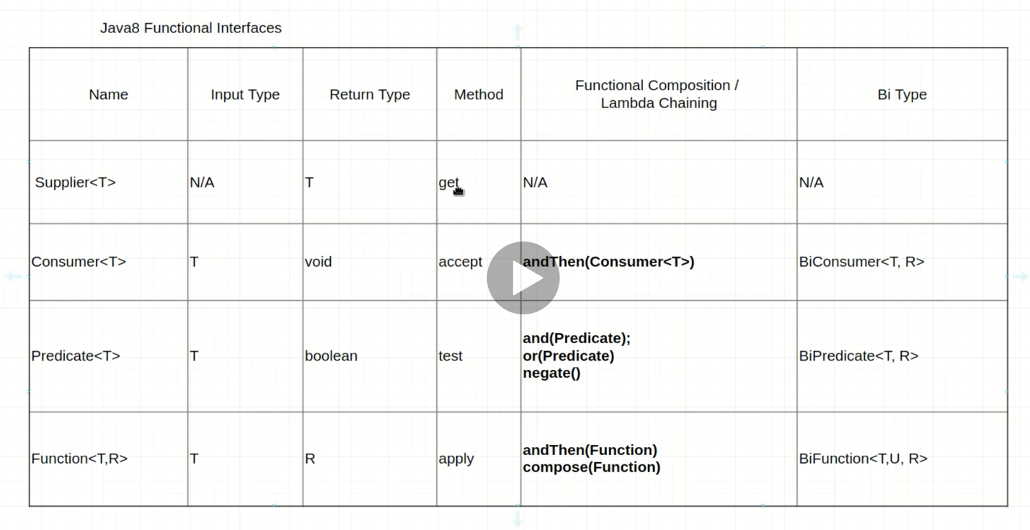

// Supplier with Lambda

Supplier <Double> random = () -> {

return Math.random(); ---🡪 Method body declaration

};

System.out.println(random.get()); ---🡪 Execution

// Supplier with Method refrence

Supplier <Double> random1 = Math::random; ---🡪 Method body declaration

System.out.println(random1.get()); ---🡪 Execution

TEST AUTOMATION EXAMPLE

public class DriverFactory {  
  
 private static final Supplier<WebDriver> *chromeSupplier* = () -> {  
 WebDriverManager.*chromedriver*().setup();  
 return new ChromeDriver();  
 };  
  
 private static final Supplier<WebDriver> *firefoxSupplier* = () -> {  
 WebDriverManager.*firefoxdriver*().setup();  
 return new FirefoxDriver();  
 };  
  
 private static final Map<String, Supplier<WebDriver> > *DRIVERPOOL* = new HashMap<>();  
  
 static {  
 *DRIVERPOOL*.put("chrome",*chromeSupplier*);  
 *DRIVERPOOL*.put("firefox",*firefoxSupplier*);  
 }  
  
 public static WebDriver getDriver(String browser){  
 return *DRIVERPOOL*.get(browser).get();  
 }  
  
}

public class TestDrivers {  
  
 private WebDriver driver;  
  
 @BeforeTest  
 @Parameters("browser")  
 public void setDriver(@Optional("firefox") String browser){  
 driver = DriverFactory.*getDriver*(browser);  
  
 }  
  
 @Test  
 public void firstTest(){  
 driver.get("https://google.com");  
 }  
  
 @AfterTest  
 public void tearDown(){  
 driver.close();  
 }  
}

----- CONSUMER -----

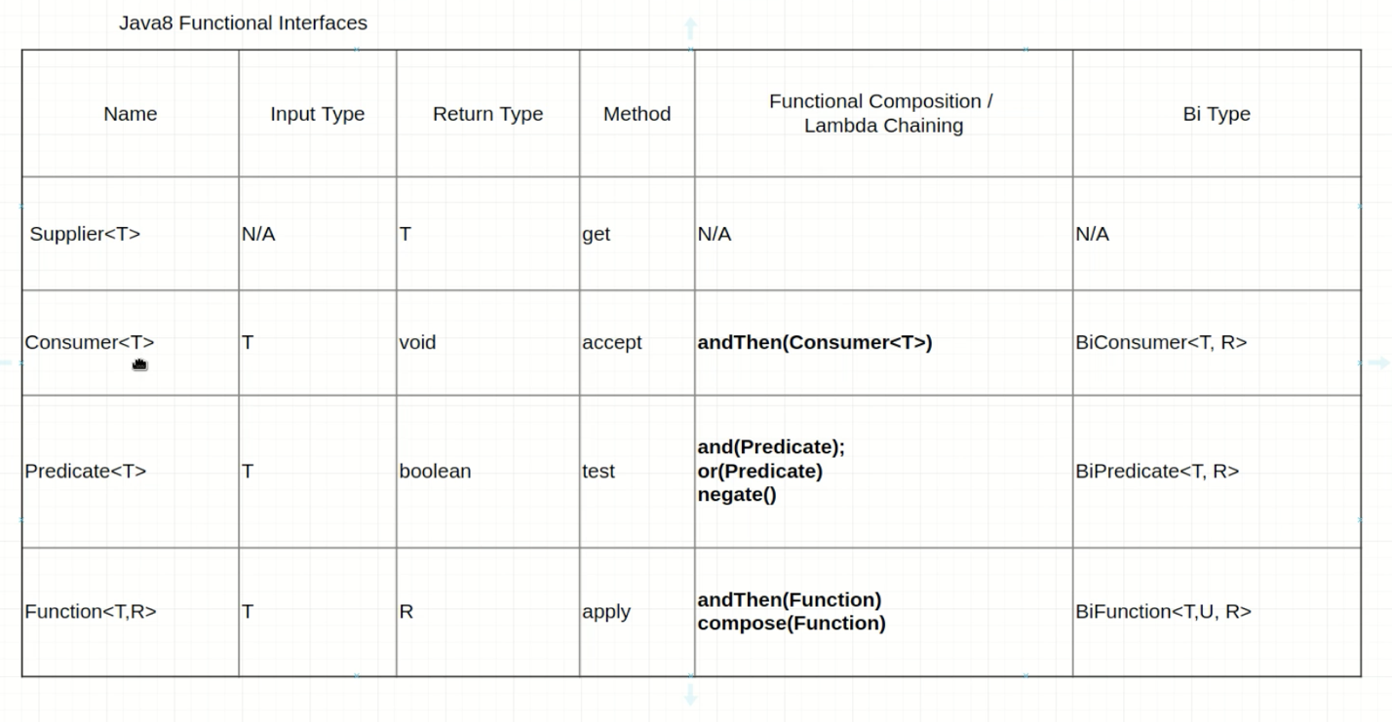

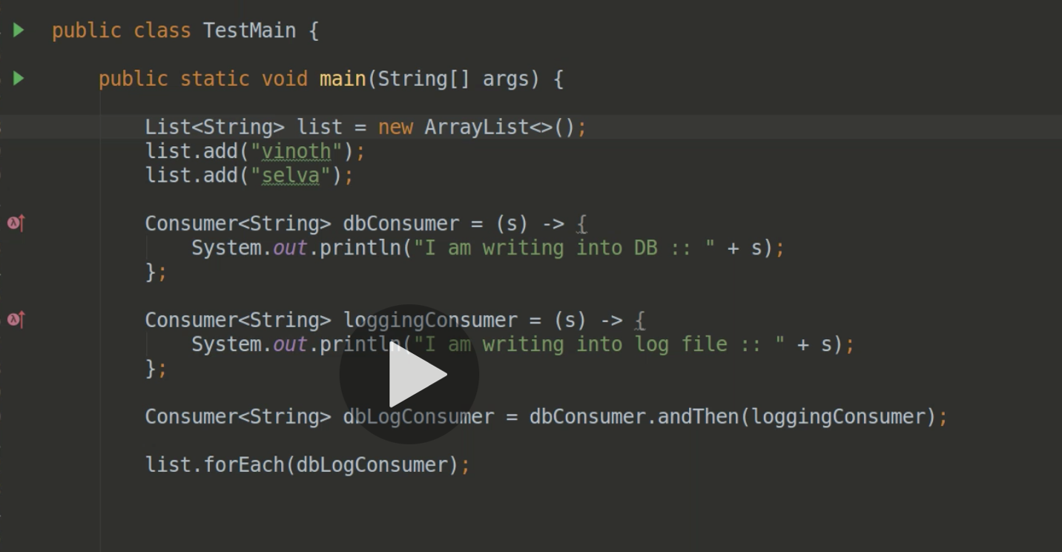

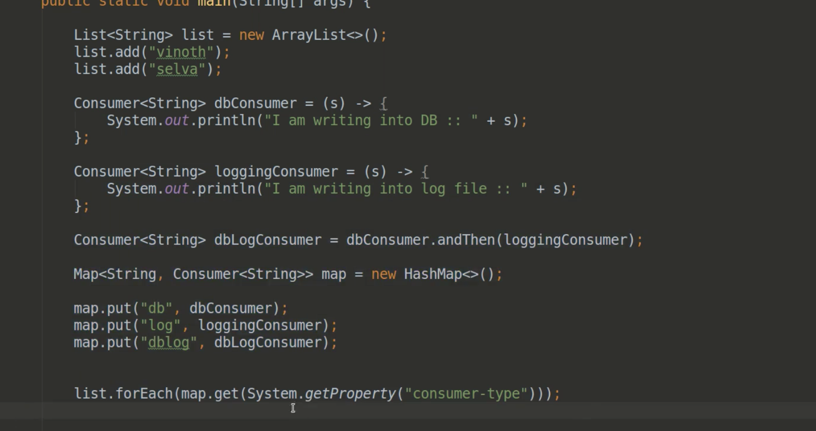

----- PREDICATE -----

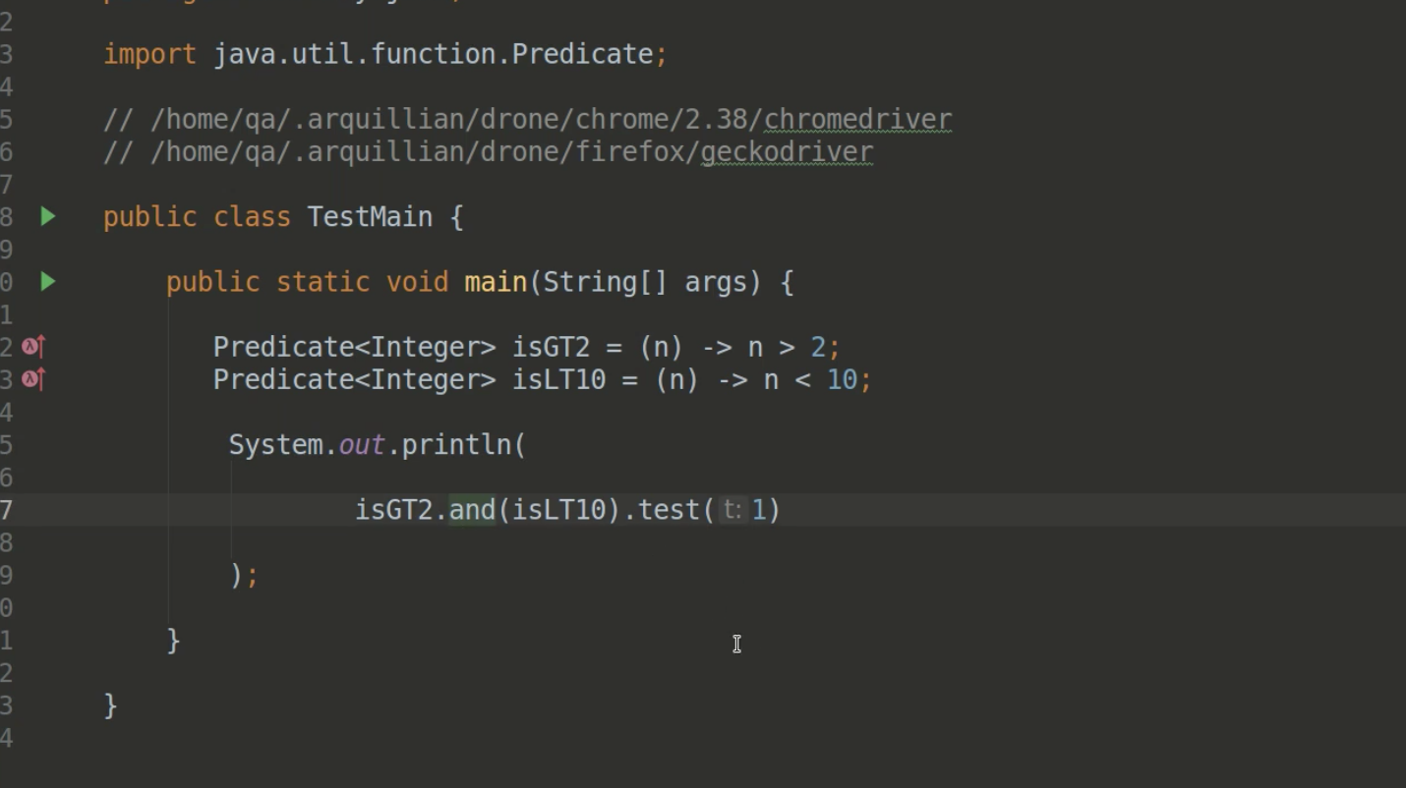

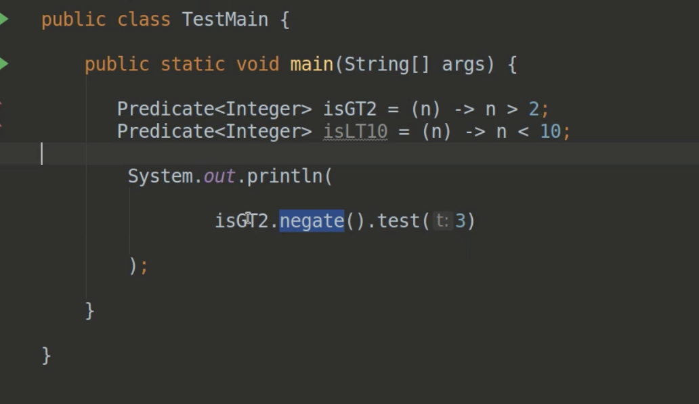

Automation example;

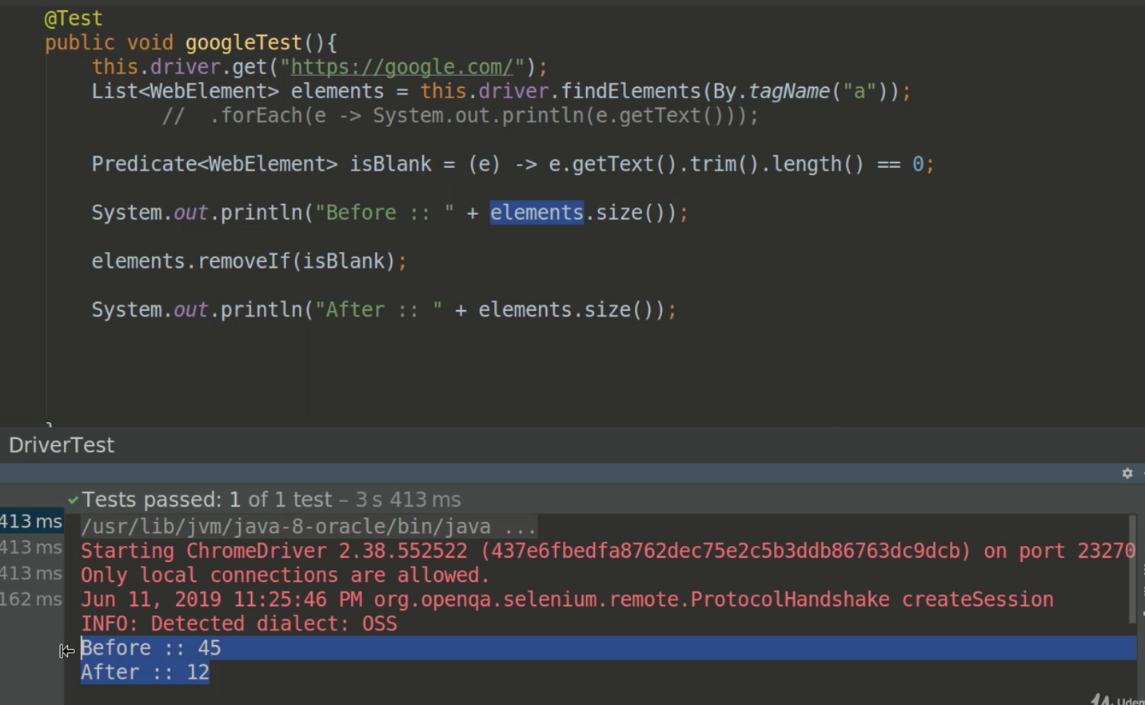

What will happen if we have 100’s of rules ?

So we create a rules class which contains predicates.

public class Main {  
  
 public static void main(String[] args) {  
  
 List<String> names = new ArrayList<>();  
  
 names.add("Ahmet");  
 names.add("Mehmet");  
 names.add("Cengiz");  
 names.add("Osman");  
 names.add("Ali");  
 names.add("Ahmet");  
 names.add("Kerim");  
 names.add("Serhat");  
  
 // Rule-1 : Remove the names with start "A"  
 System.*out*.println("Before remove :: "+names);  
// for (int i=0; i<names.size(); i++) {  
// if (names.get(i).toUpperCase().charAt(0) == 'A'){  
// names.remove(names.get(i));  
// i--;  
// } else {  
// System.out.println(names.get(i) + "'s first letter is not equal to 'A'");  
// }  
// }  
  
// Predicate<String> isFirstLetterA = (name) -> name.toUpperCase().charAt(0) == 'A';  
// Predicate<String> isLastLetterT = (name) -> name.toLowerCase().endsWith("t");  
// names.removeIf(isFirstLetterA);  
// names.removeIf(isLastLetterT);  
  
 Rules.*getConditions*().forEach(rule -> names.removeIf(rule));  
  
// names.removeIf(isFirstLetterA.or(isLastLetterT));  
 System.*out*.println("After remove :: "+names);  
  
 }  
  
}  
  
class Rules{  
  
 private static final Predicate<String> *isFirstLetterA* = (name) -> name.toUpperCase().charAt(0) == 'A';  
 private static final Predicate<String> *isLastLetterT* = (name) -> name.toLowerCase().endsWith("t");  
  
 public static List <Predicate<String>> getConditions(){  
 List <Predicate<String>> list = new ArrayList<>();  
 list.add(*isFirstLetterA*);  
 list.add(*isLastLetterT*);  
 return list;  
 }  
  
}

STREAM KEY VIDEOS : 84, 87

STREAM KEY NOTES

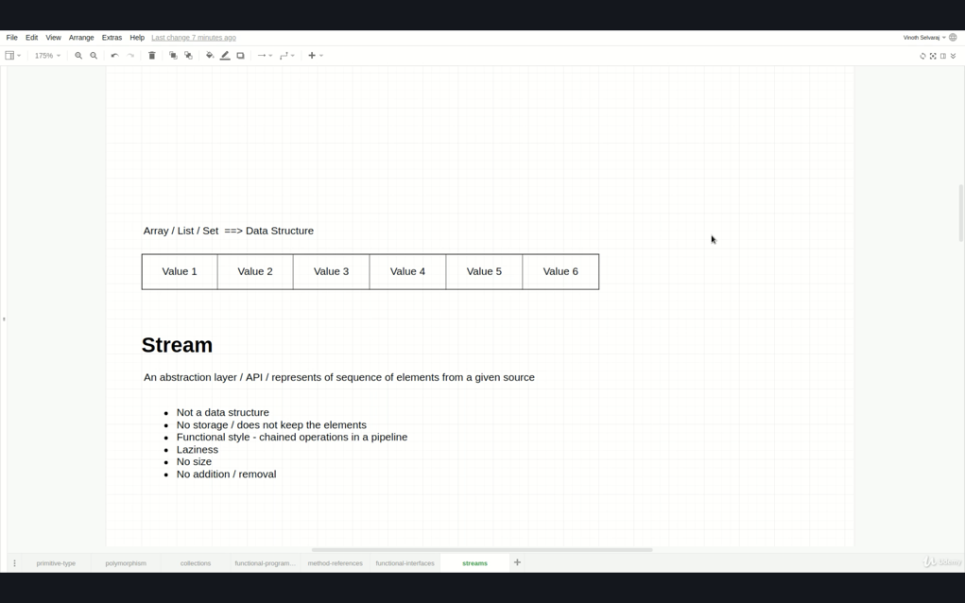

1/ To fetch data from any collection with traditional way, it’s developers’ responsibility to fetch the data, but in stream data slides from the collection and you filter it accordingly. So, it’s not developers’ responsibility to fetch the data correctly. For example, in traditional way while looping, index out of exception might come, to handle this, it’s developer’s responsibility.

2/

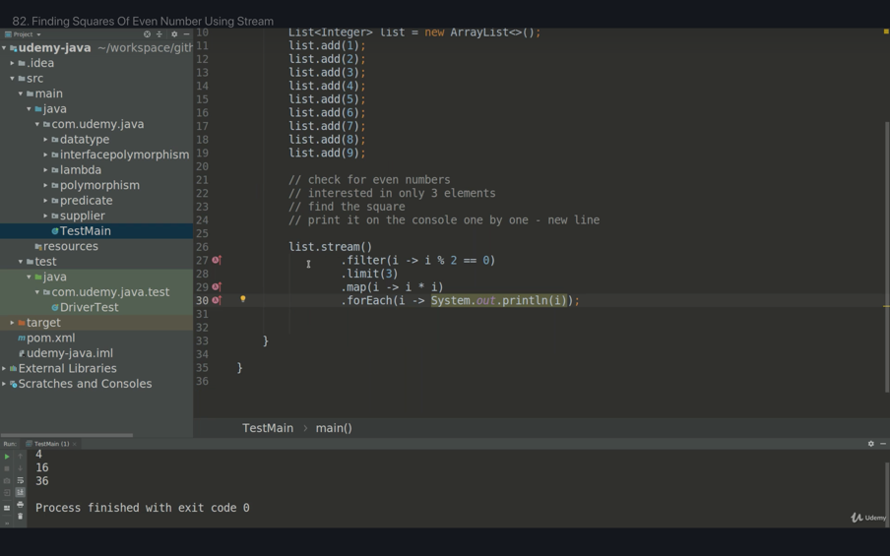

3/ Stream pipeline is basically set of operations to be performed. In this example first operation is filter, second one is limit, and third one is finding the square. Data slides from the collection one by one and the stream flow is completed from top to bottom from each and every data. And in this example since the developer limit only 3 data after 3th data it doesn’t get other data. You are ready to access to elements one by one. If a collection has billion numbers and the developers limit with only 3 numbers, java stream is extremely smart it only takes those 3 numbers and it doesn’t filter the rest of billion numbers. Each data complete the pipeline one by one.

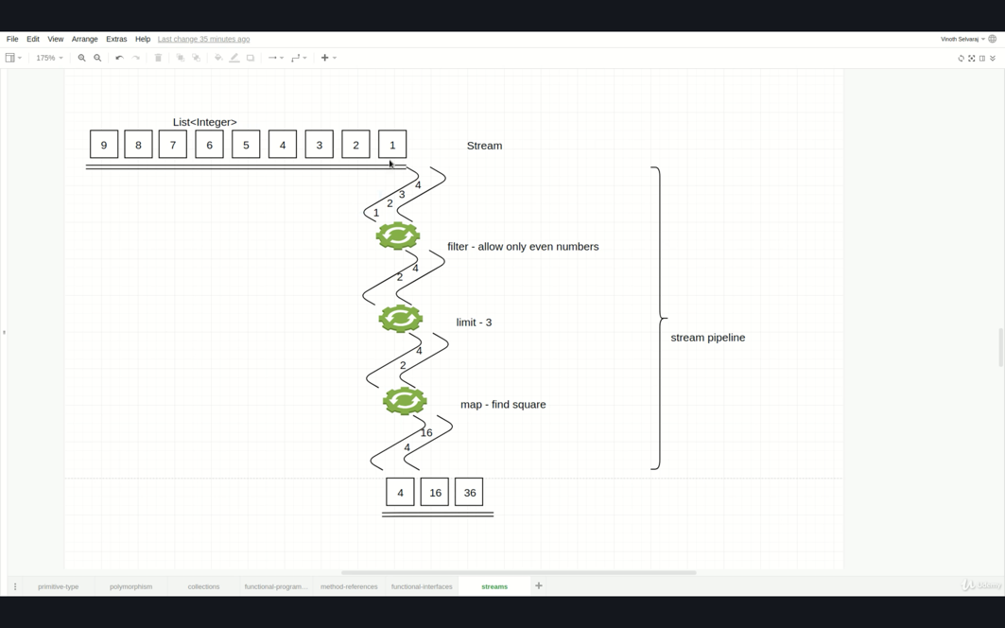

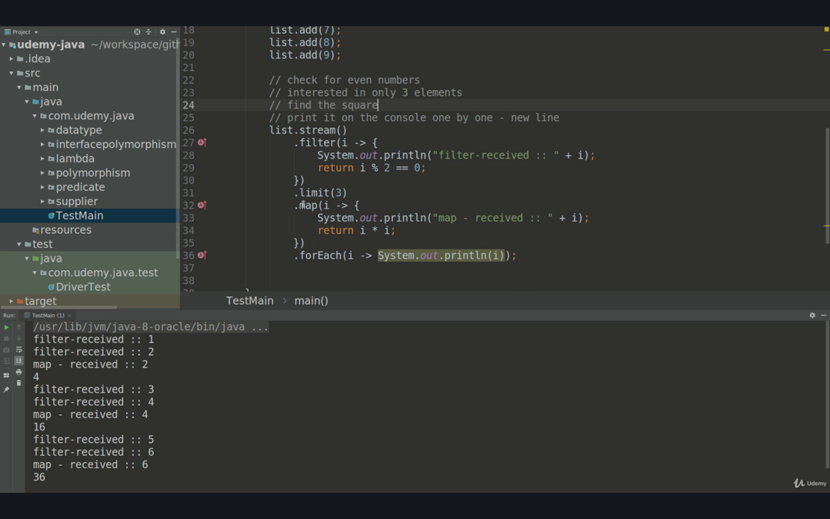

Intermediate operations can be used multiple times but terminal operations can be used only once

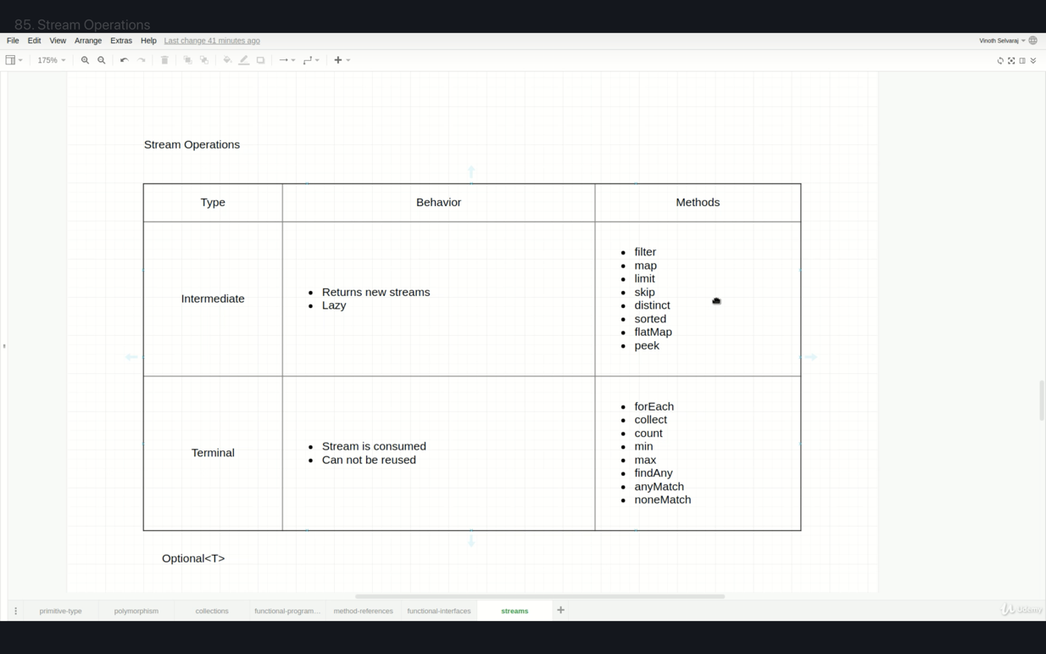

Stream laziness : If there is no terminal operator than those intermediate operations are nonfunctional. See the picture below;

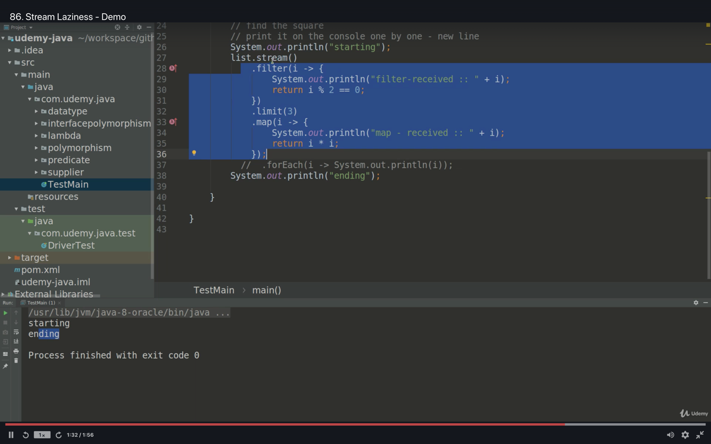

VIDEO 87 and below slide explains the intermediate operations, of course the most useful ones;

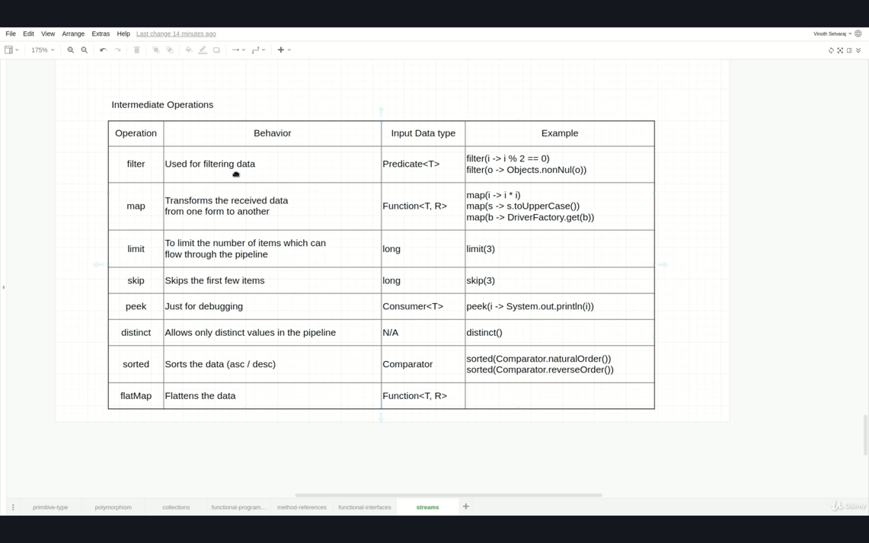

map() is the only operator witch changes the data type, it can convert from string to integer or it can convert from integer to string so, it’s different than other intermediate operators. Those operators don’t change the data type.

\*\* good verbiage for filter() is “condition satisfied” or “not satisfied”.

sort() : this method is completely different than others, first all data/elements put into the stream pipeline and once data see the sort() method, data is stuck until all sort operation finalized and then data slides in the stream pipeline. Watch video 89 for detailed info.

In order to sort, it has to know all the data upfront.

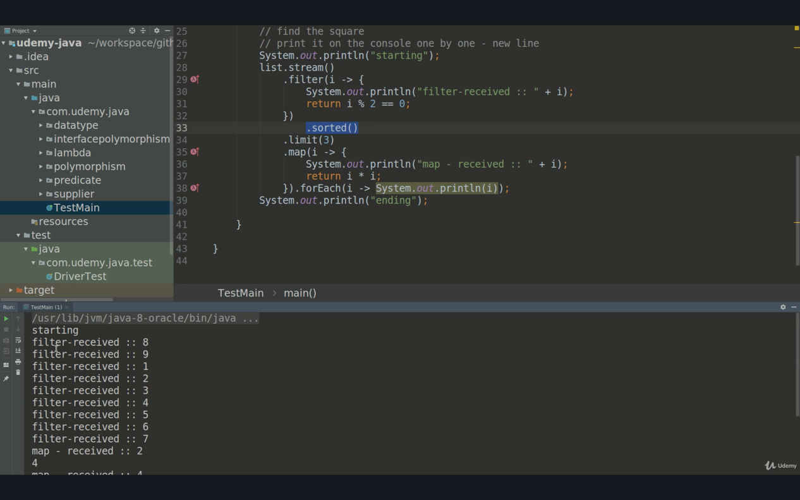

peek(): only used for debugging purposes. See the ss below; it can be commented out after debugging operation completed.

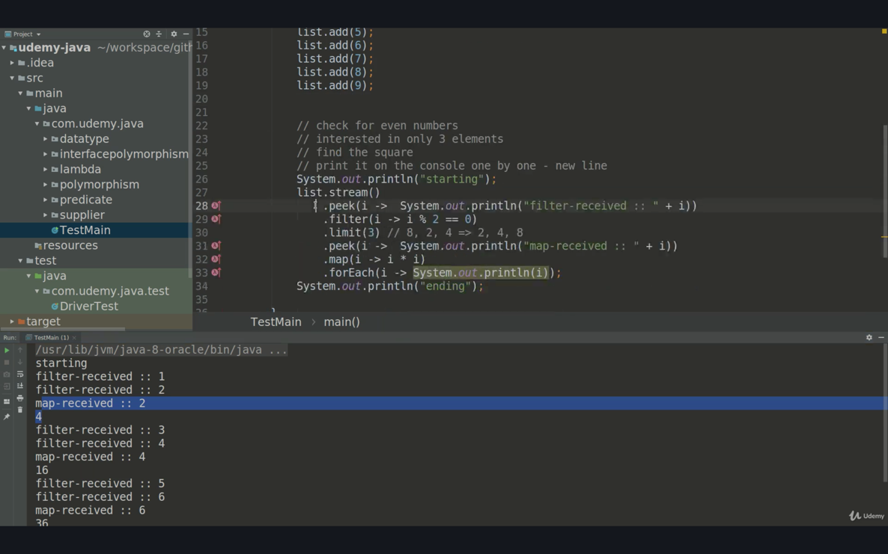

skip(i): it accepts a long value and if you want to skip n number of items, then you need to write n as an argument to skip. See ss below;

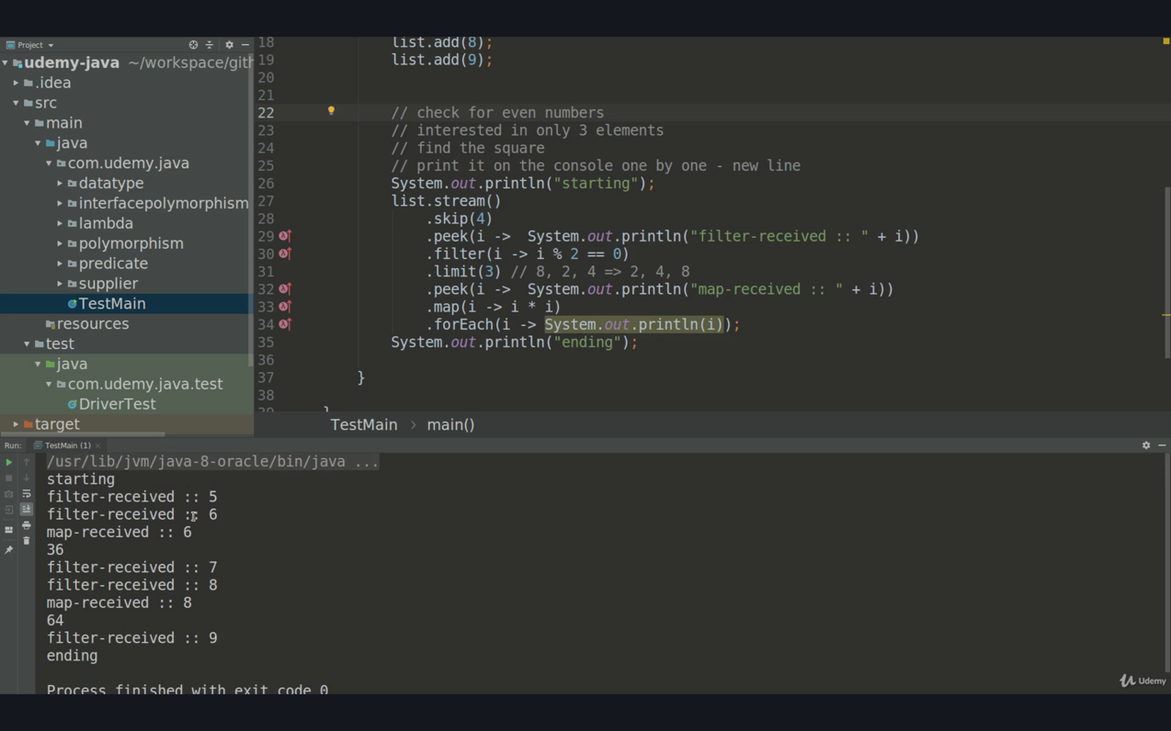

More map and filter examples; The developers can add n number of filters and map operations to stream pipeline;

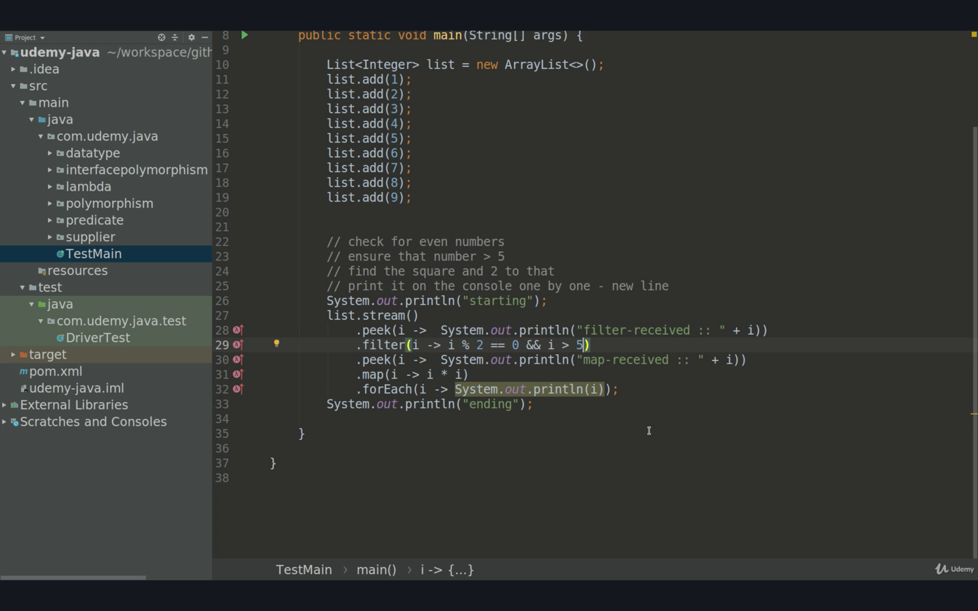

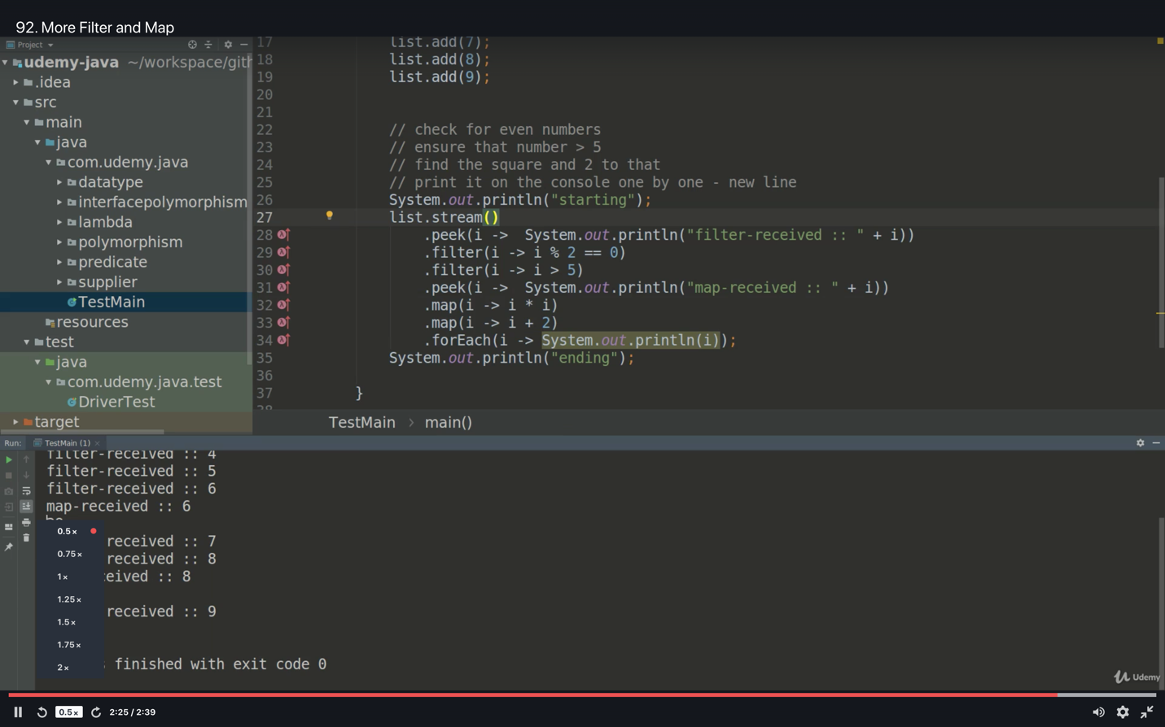

Example for stream

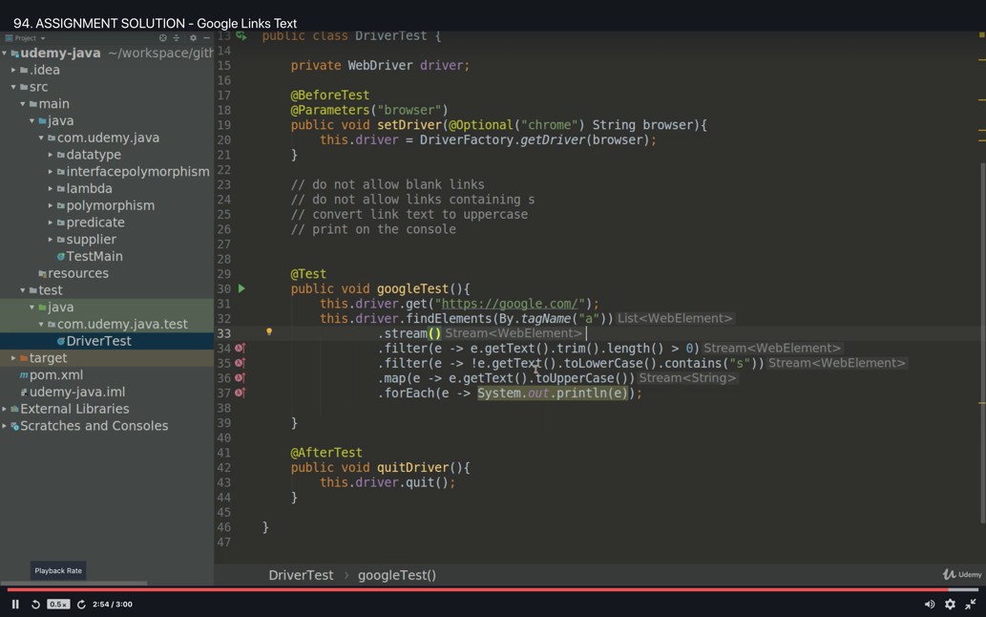

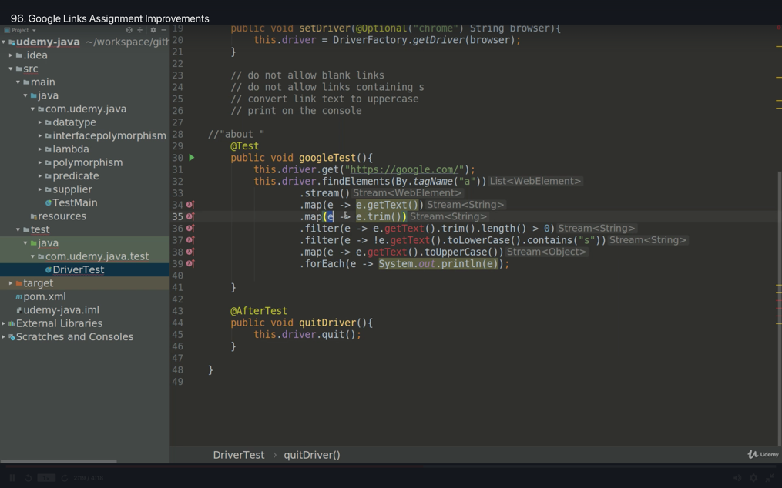

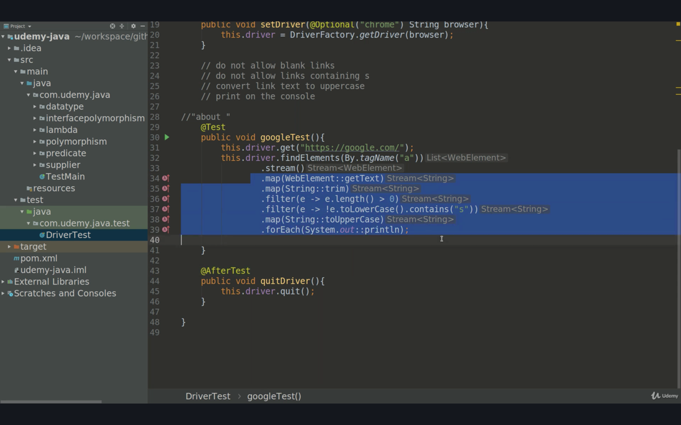

An empty list of stream;

Stream accepts the list as empty and not throw any exception.

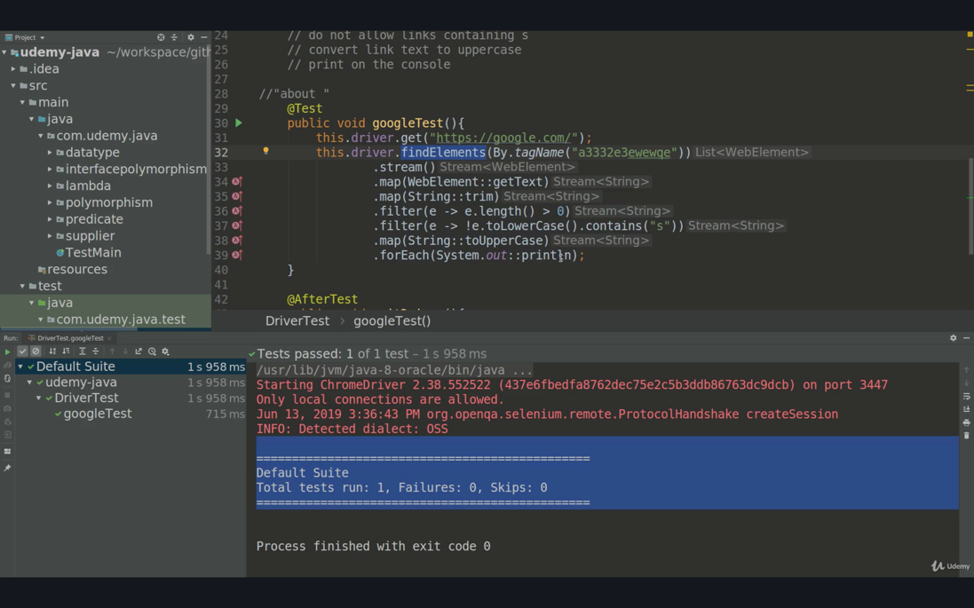

Benefit of functional programming, we can even pass predicate as a parameter like below

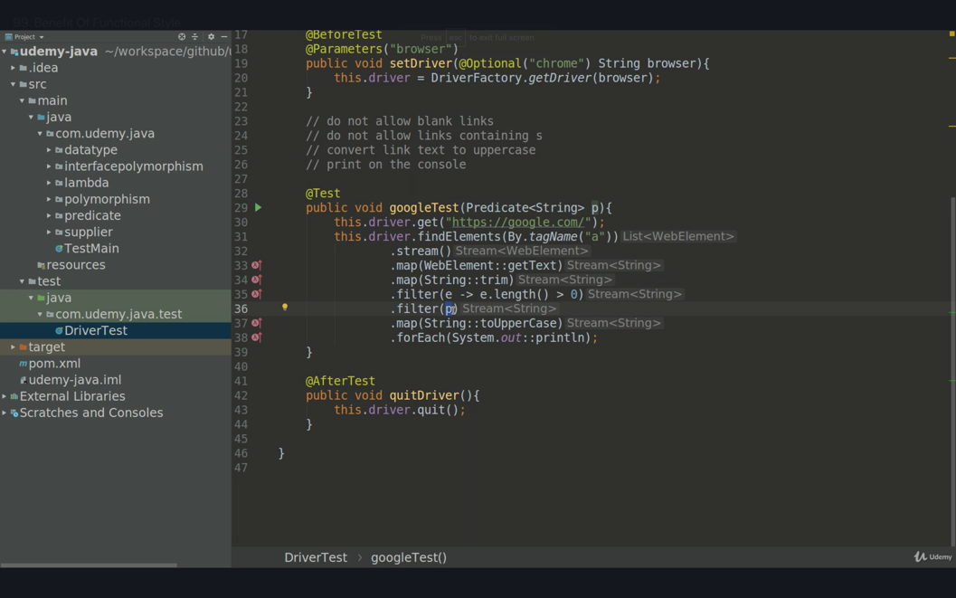

To eliminate some errors and make the test more robust we can add one more filter. Even though there is an empty tr/row in second picture, it’s working fine.

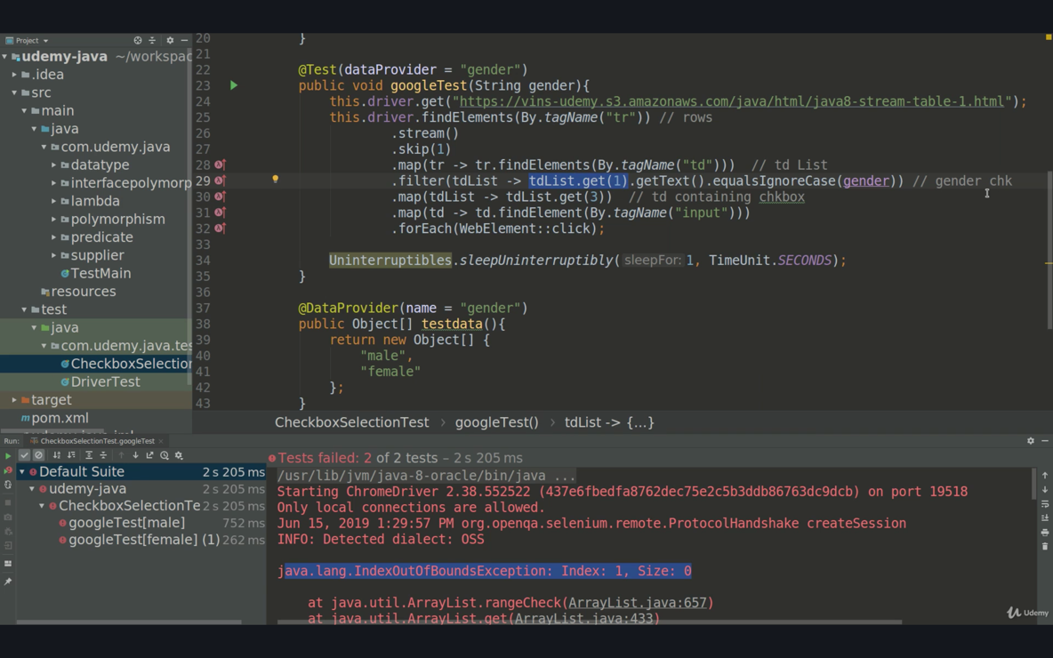

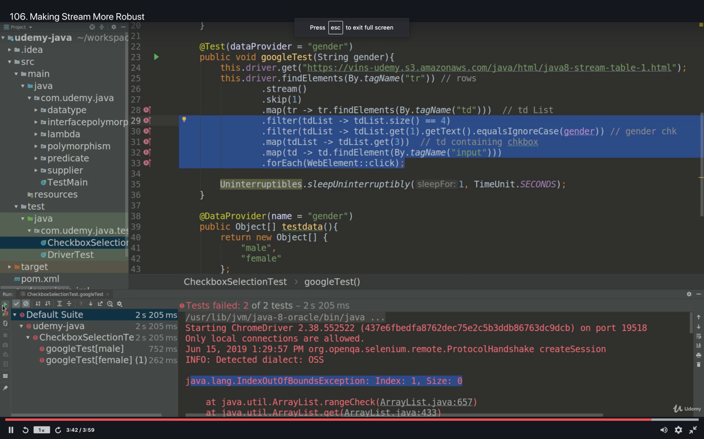

To pass predicate (condition/filter) as a parameter to make the tests more generic see below example;

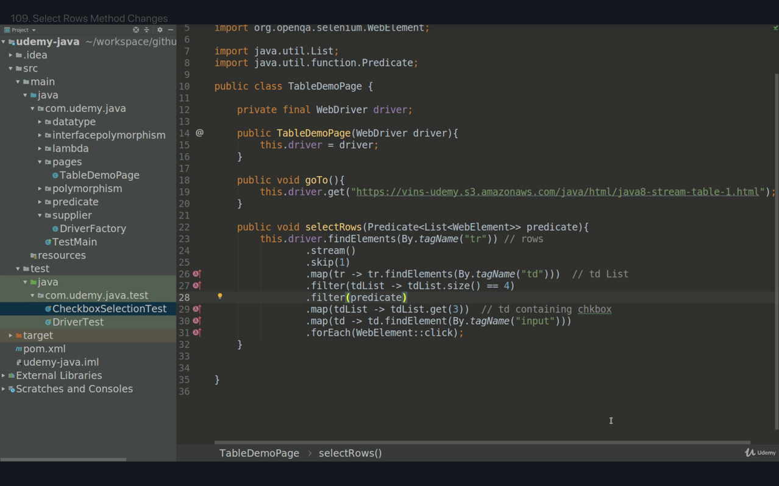

Passing predicate as a parameter

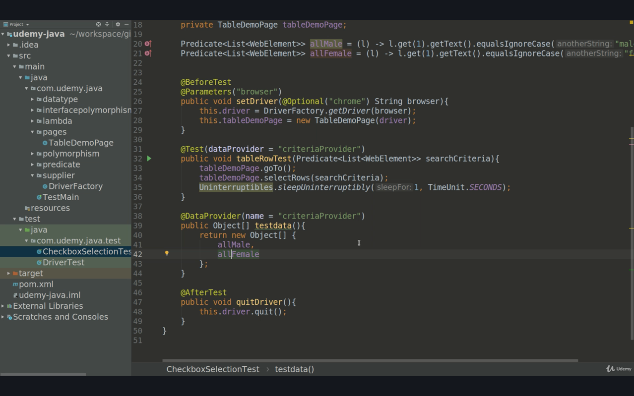

The power of lambda (functional style programming) is we don’t touch any test method or test case, we only provide different kind of data in data provider and test is working fine without any code change.

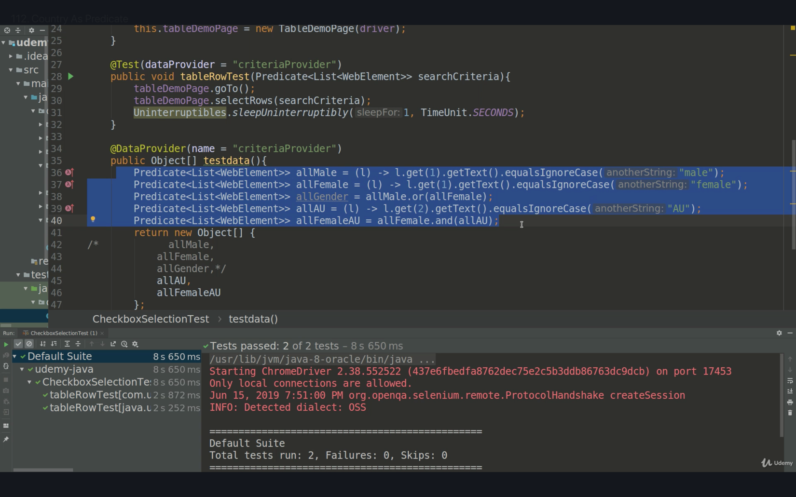

FLATMAP

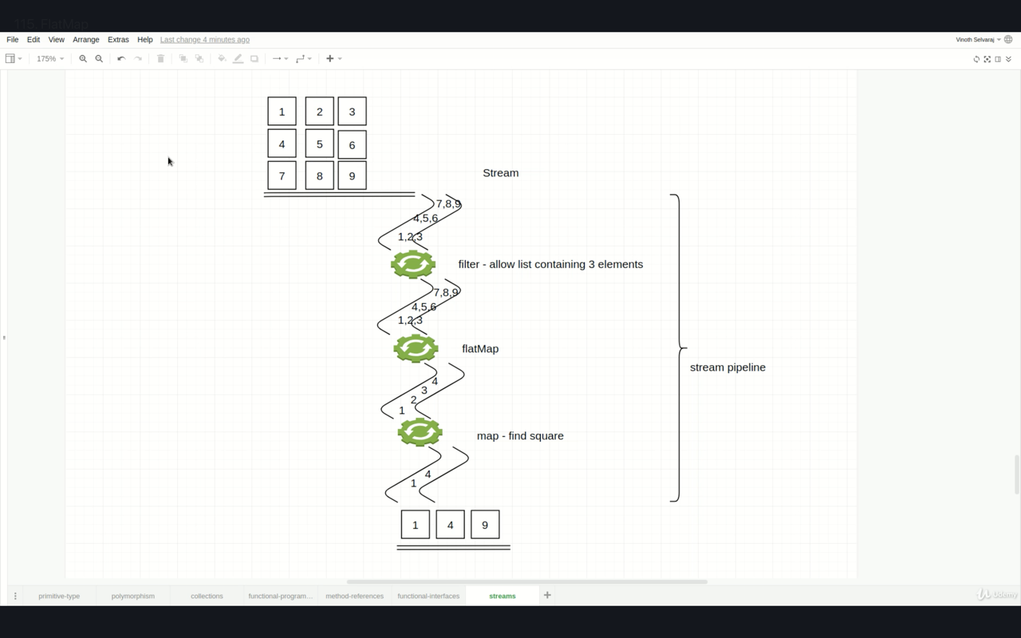

If we have a list of list and we use the stream so we will gave each list as an element into the stream, stream provides every row data but what if we want to deal with each and every element in the object.

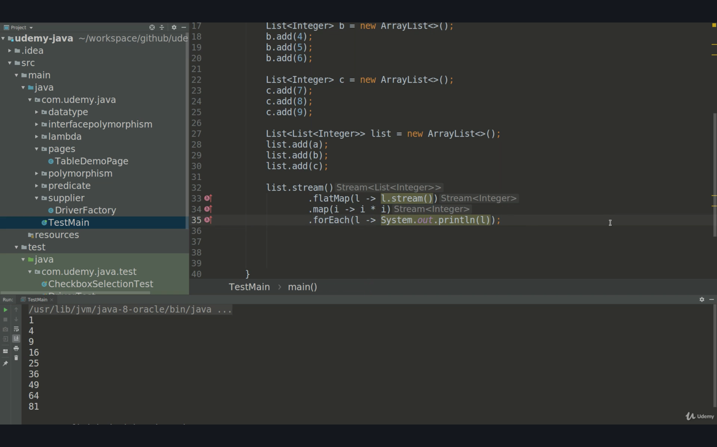

TERMINAL OPERATORS

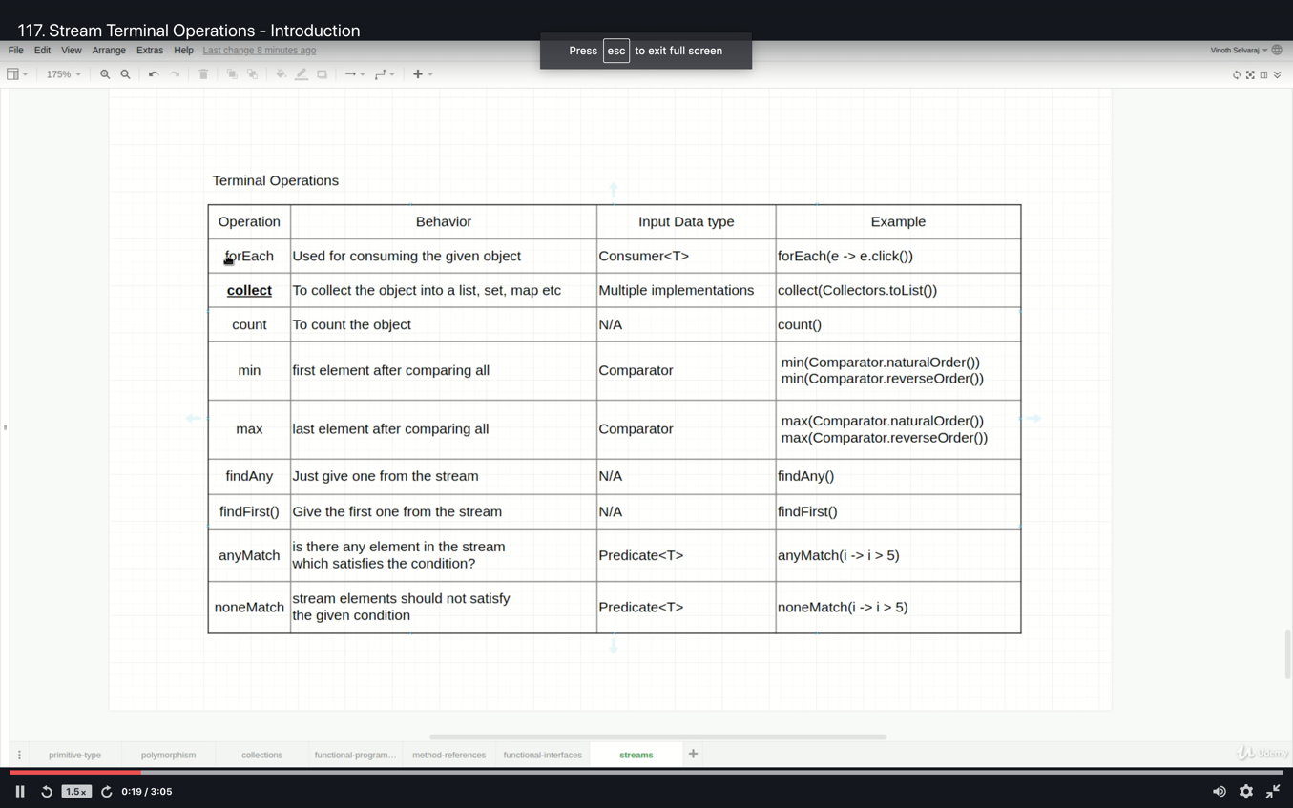

1. count()

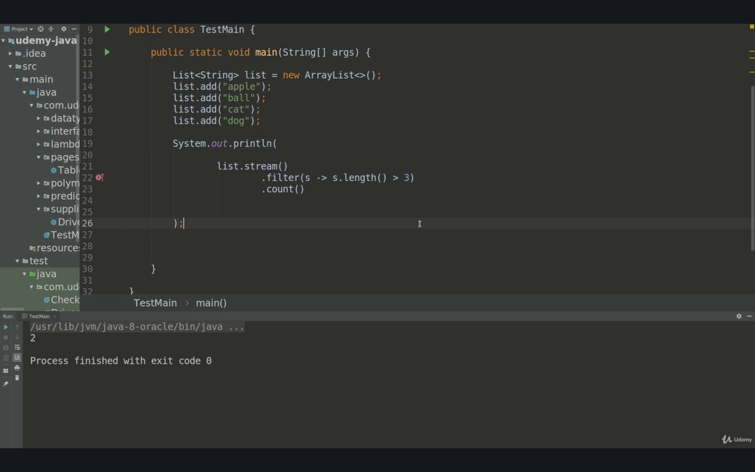

2. findFirst() & optional

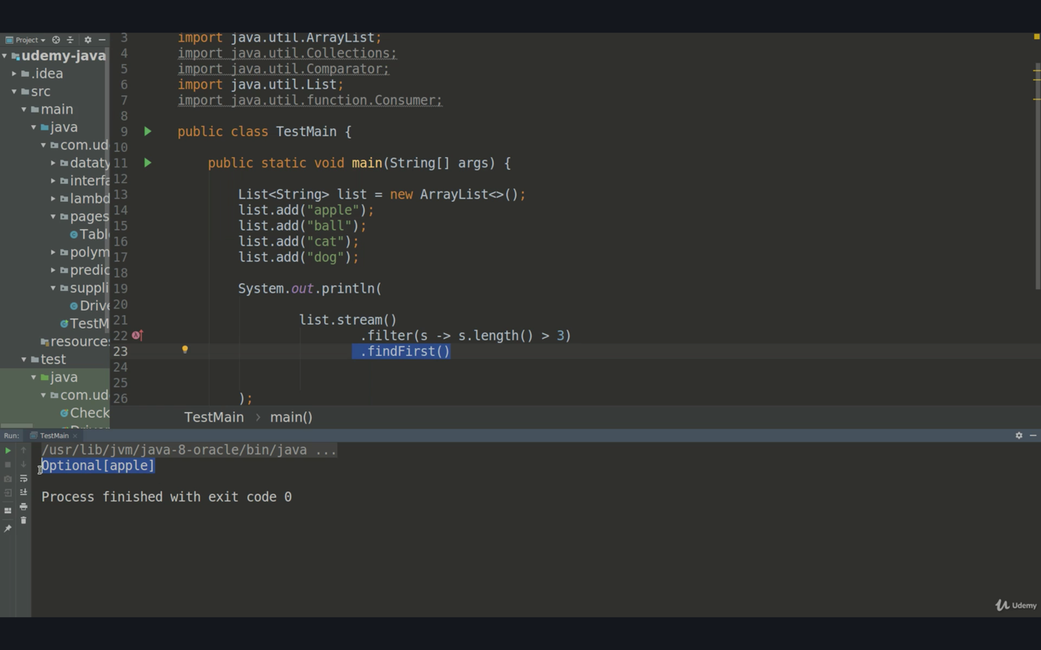

What is optional ?

If we specify condition s.length() > 100 then this condition will not be satisfied in that case we will see Optional.empty will be printed out on the console.

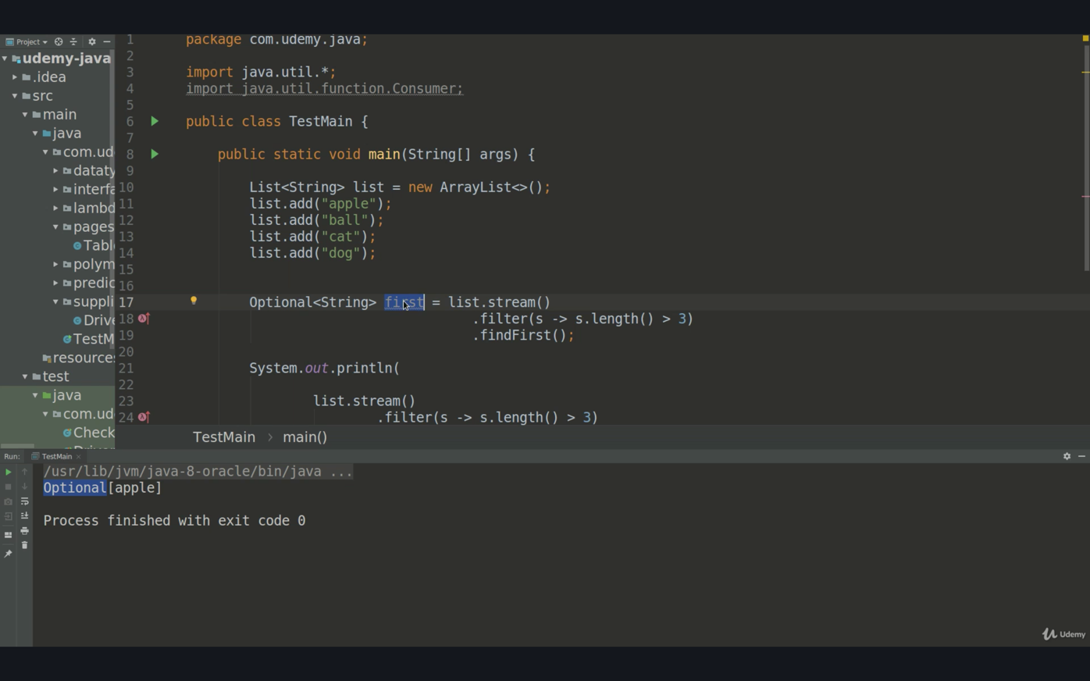

3. min() & max()

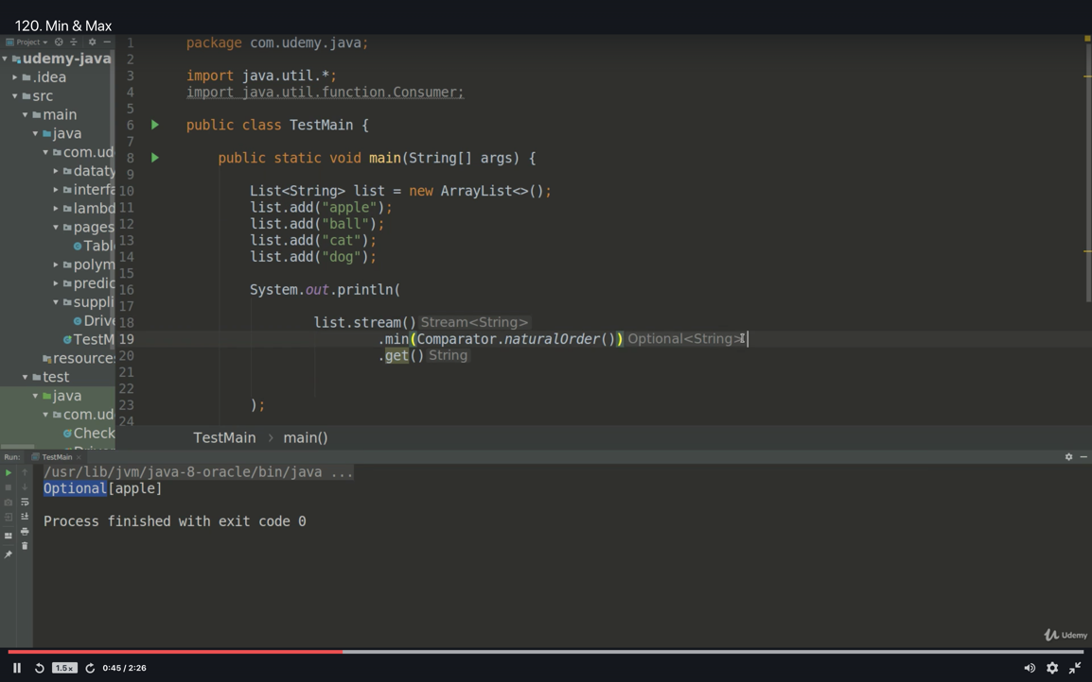

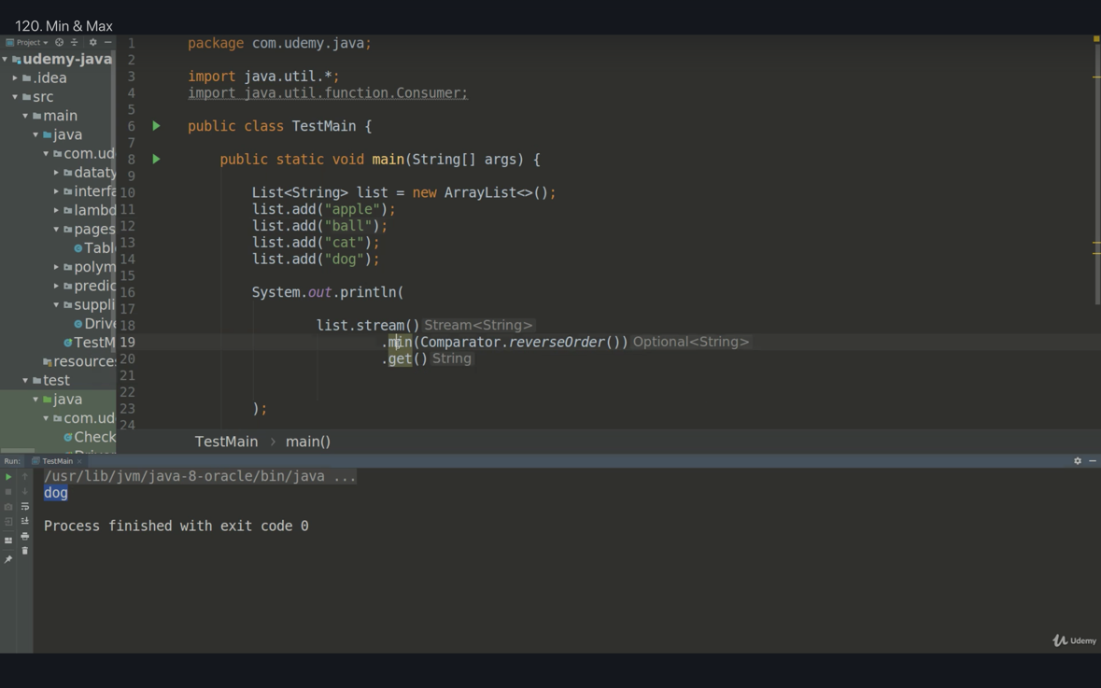

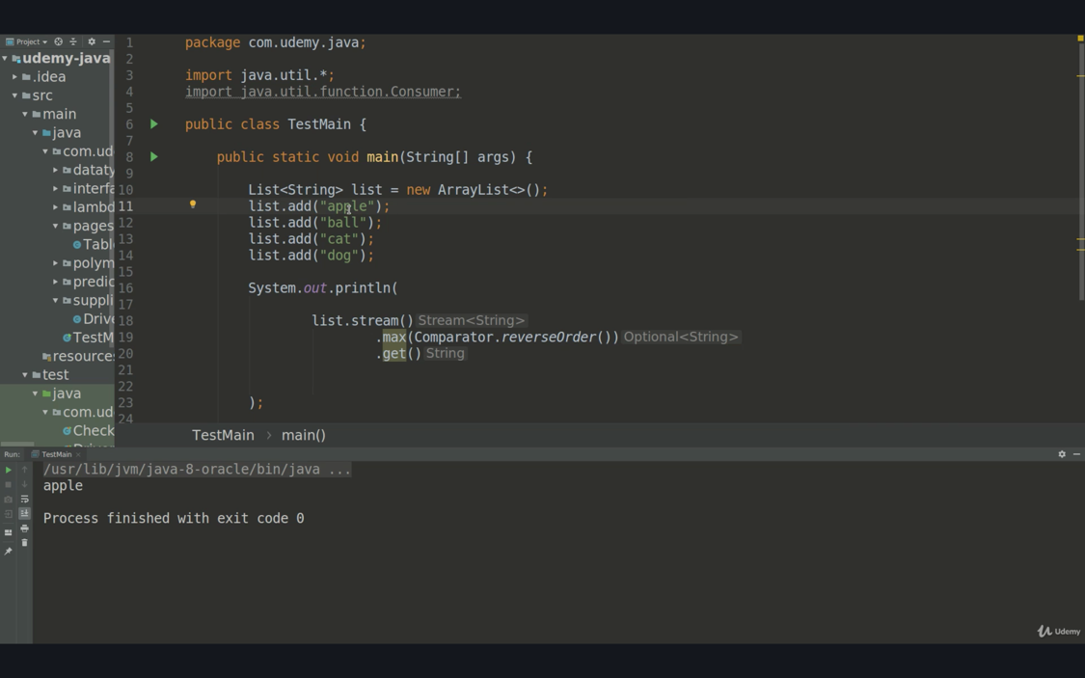

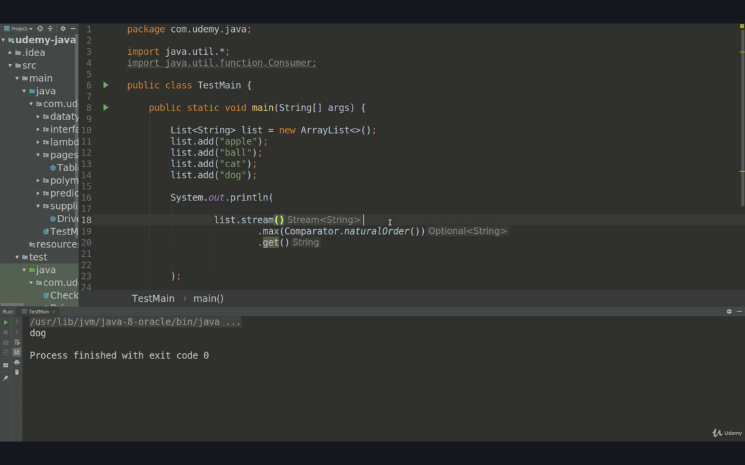

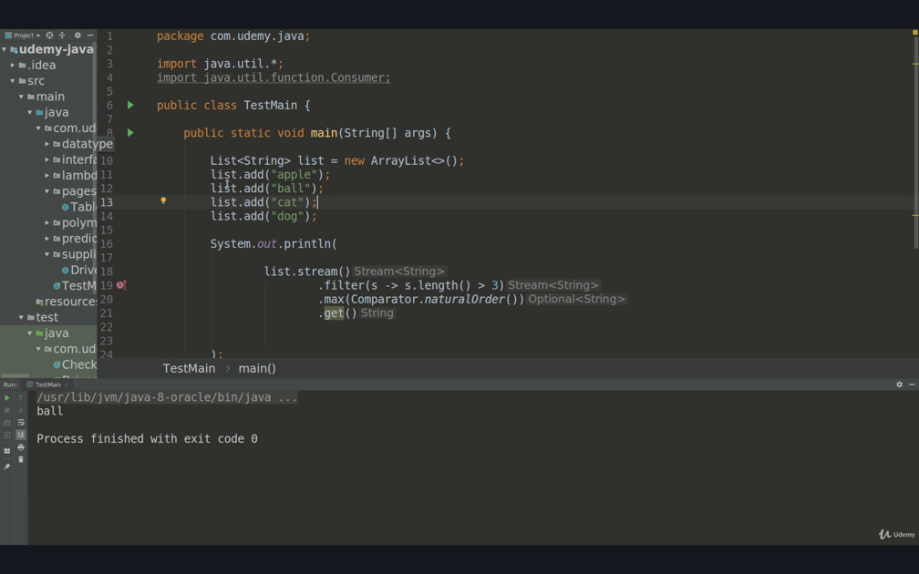

4. anyMatch(), nonmatch()

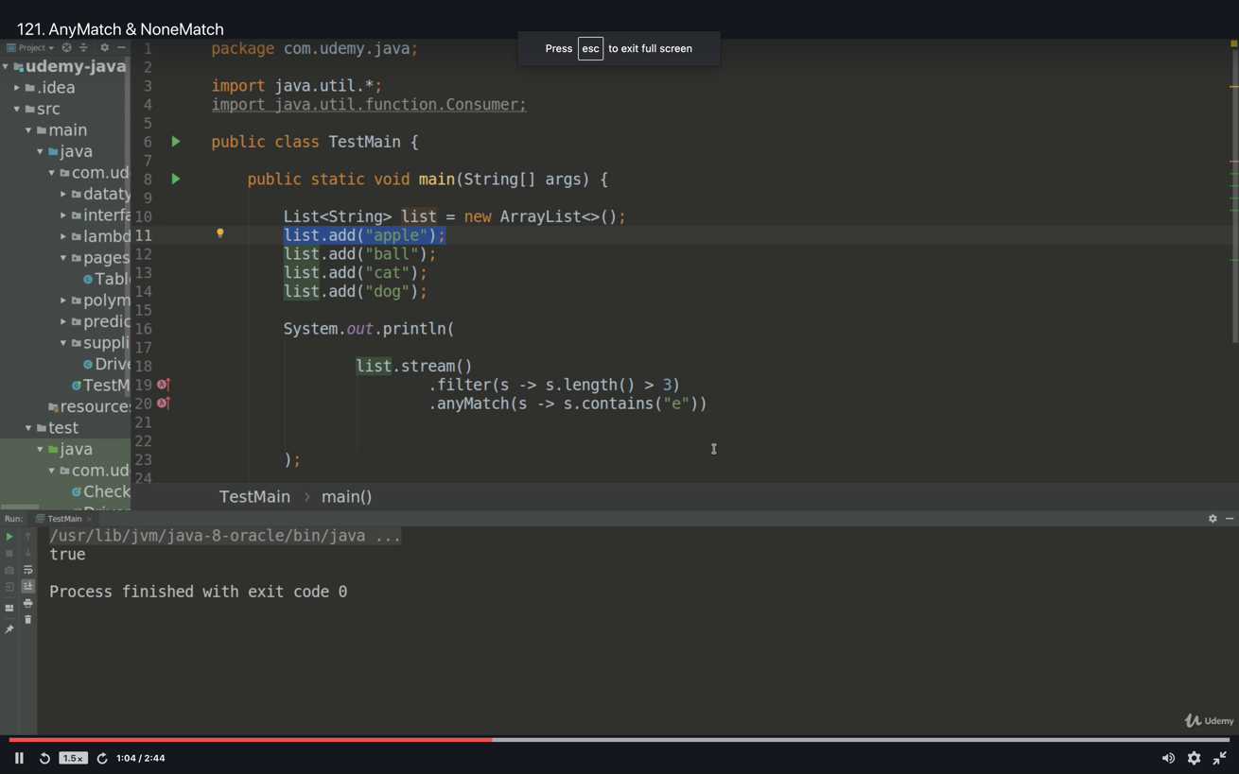

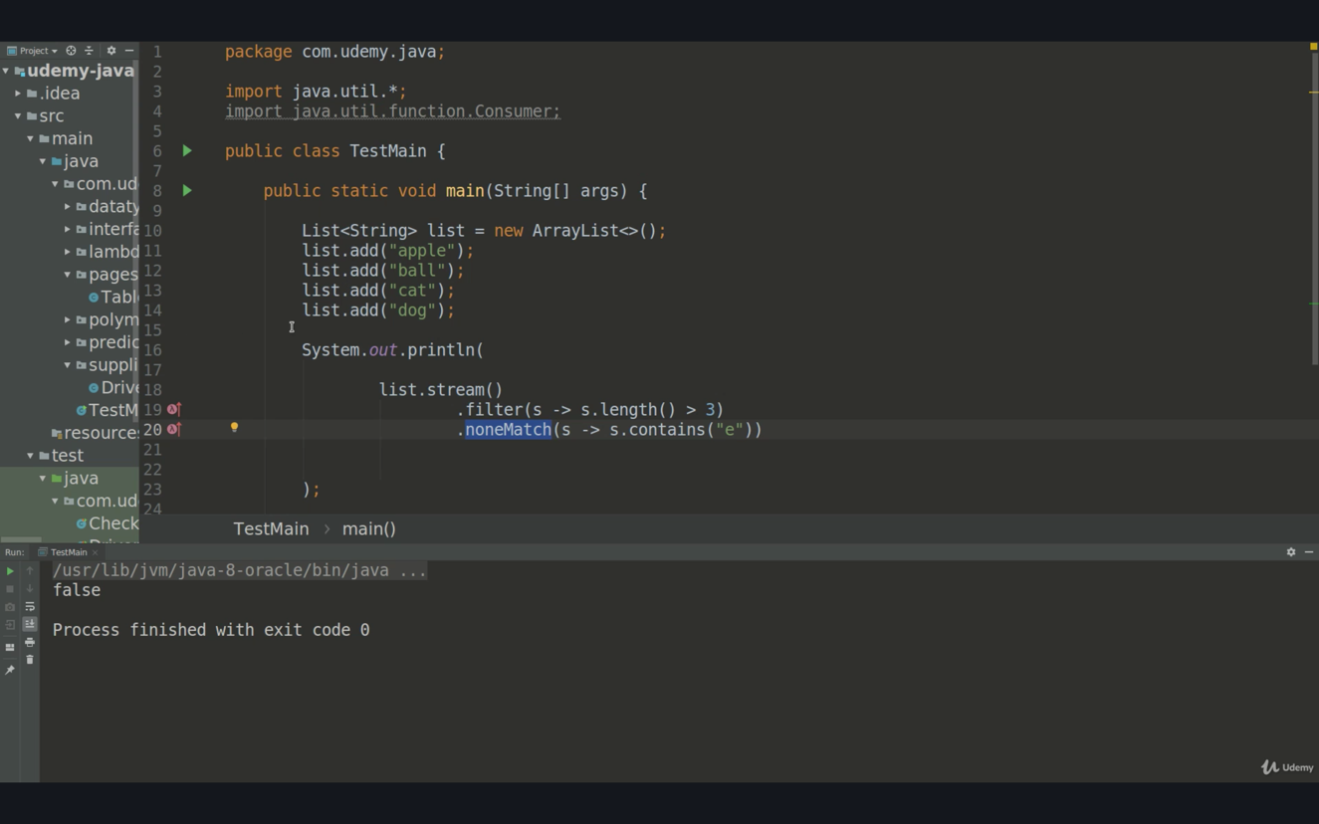

Broken Links (images) in a web page example

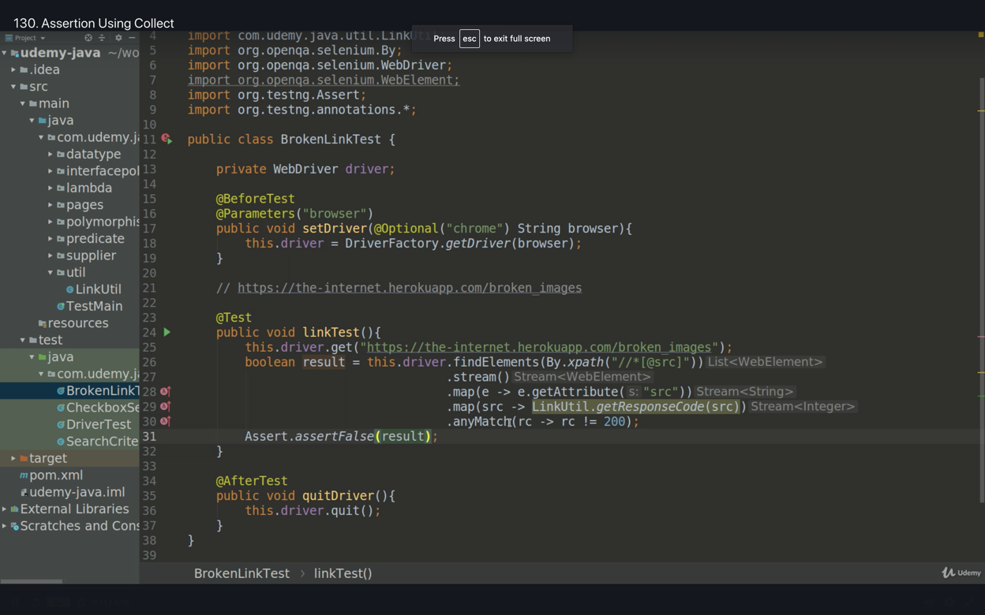

Assertions using collect()

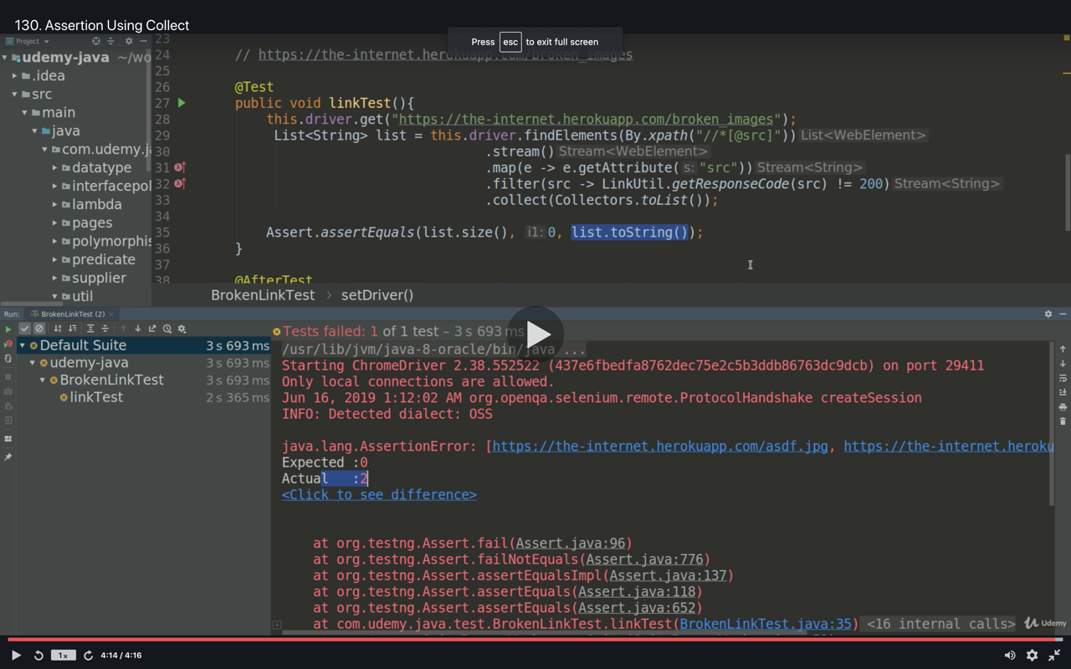

COLLECT

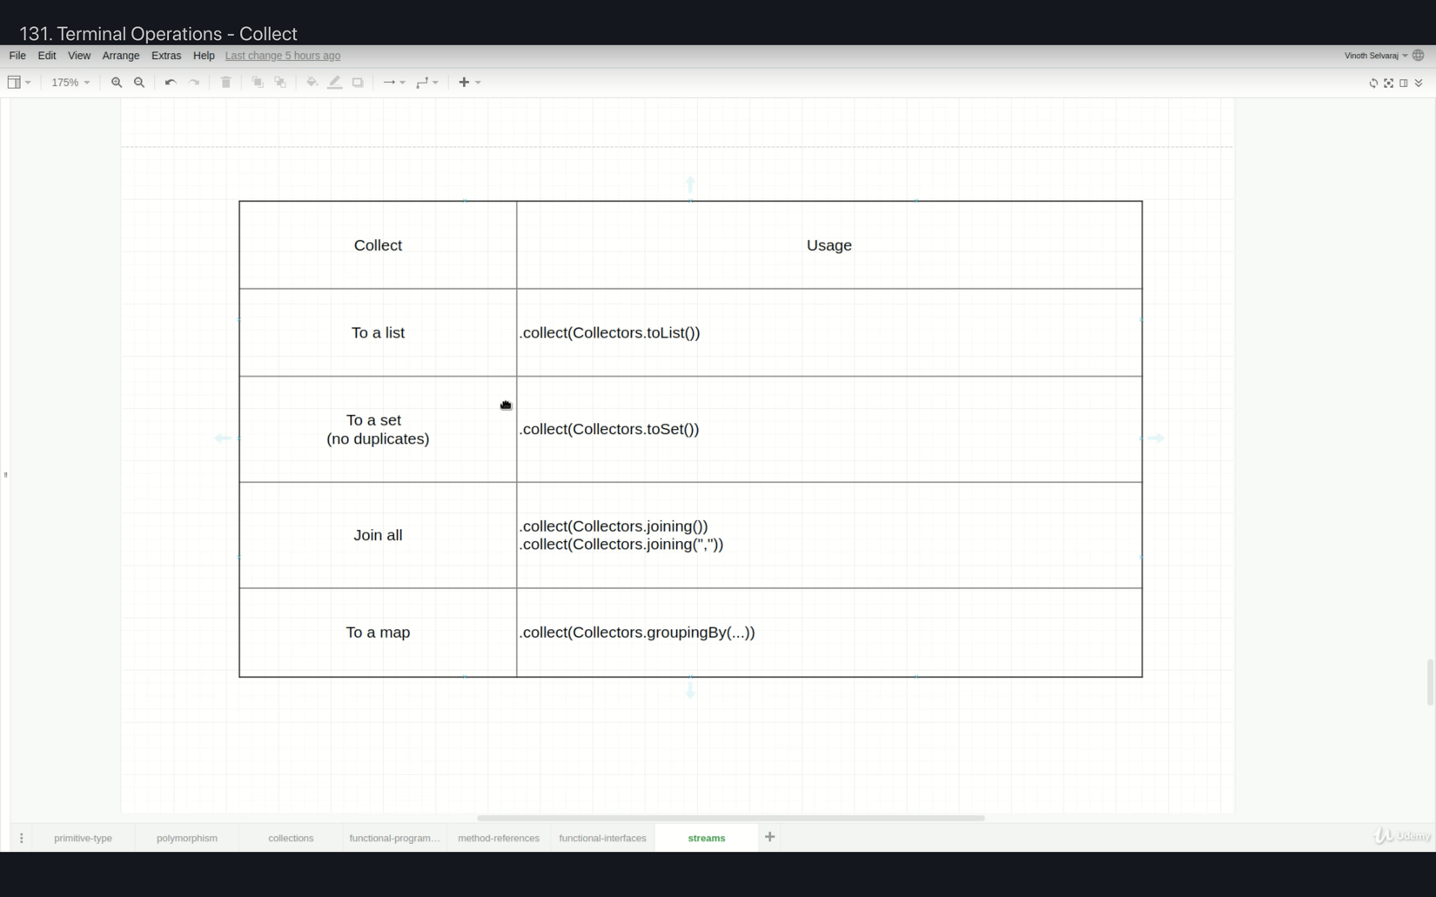

1/Collect.toList()

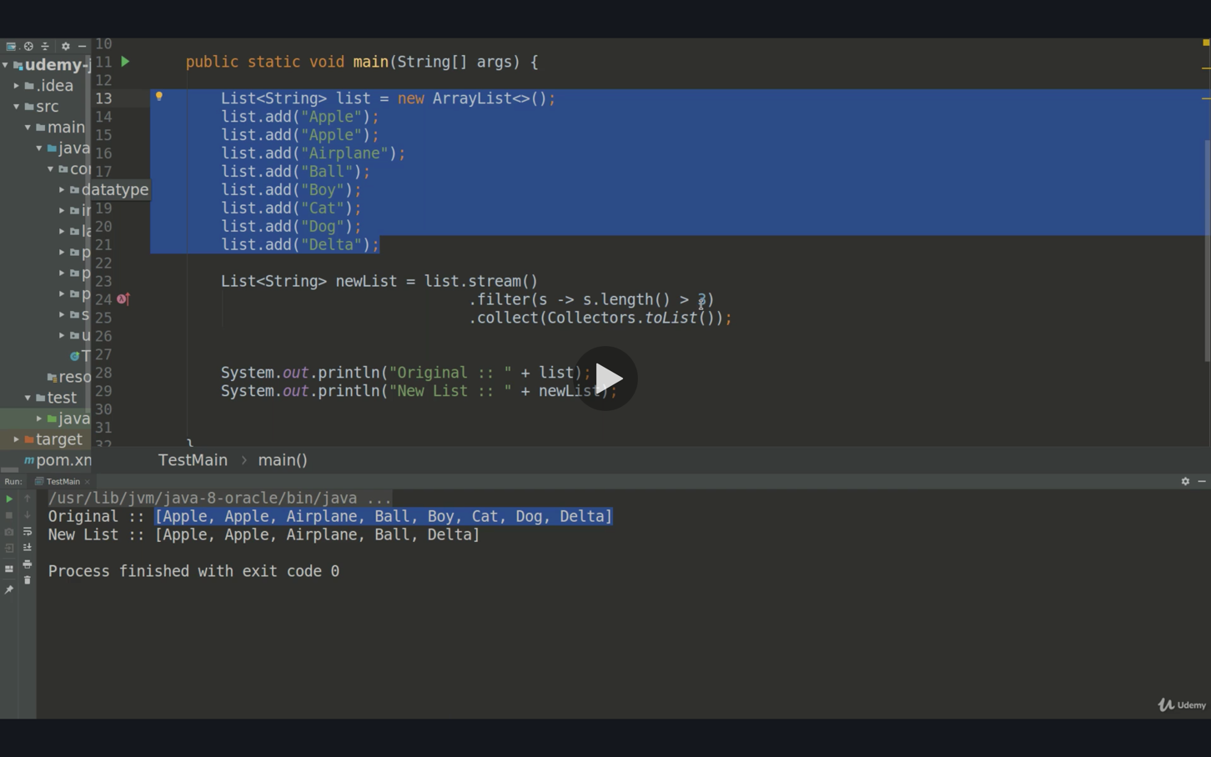

2/Collect.toSet()

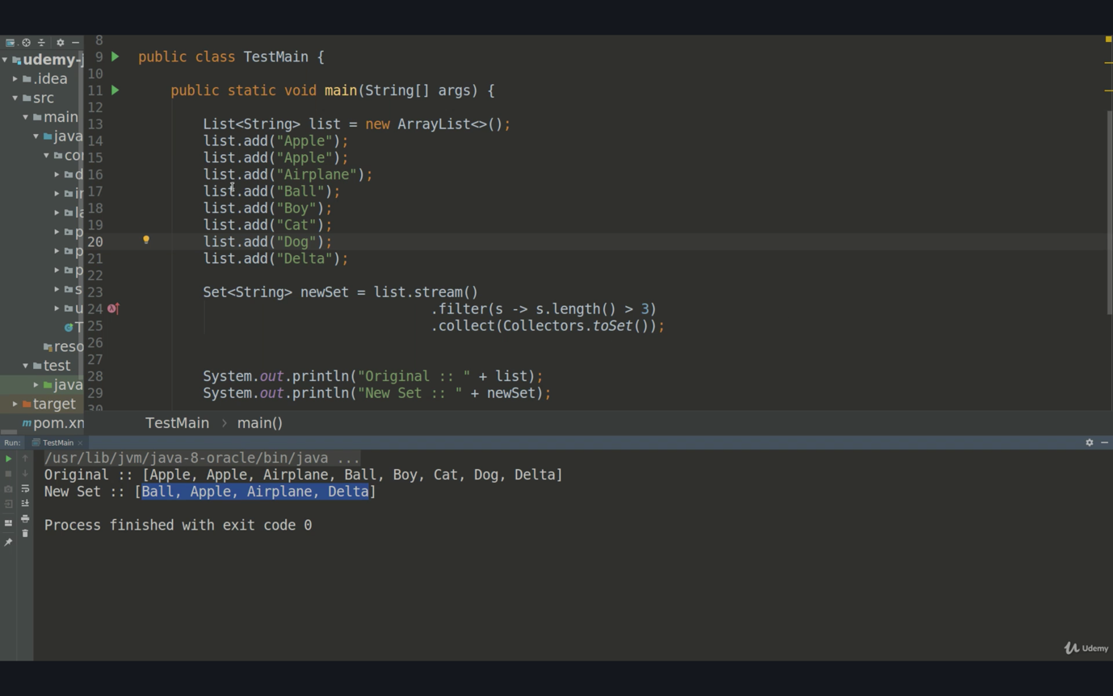

3/Collect.joining(“delimiter”)

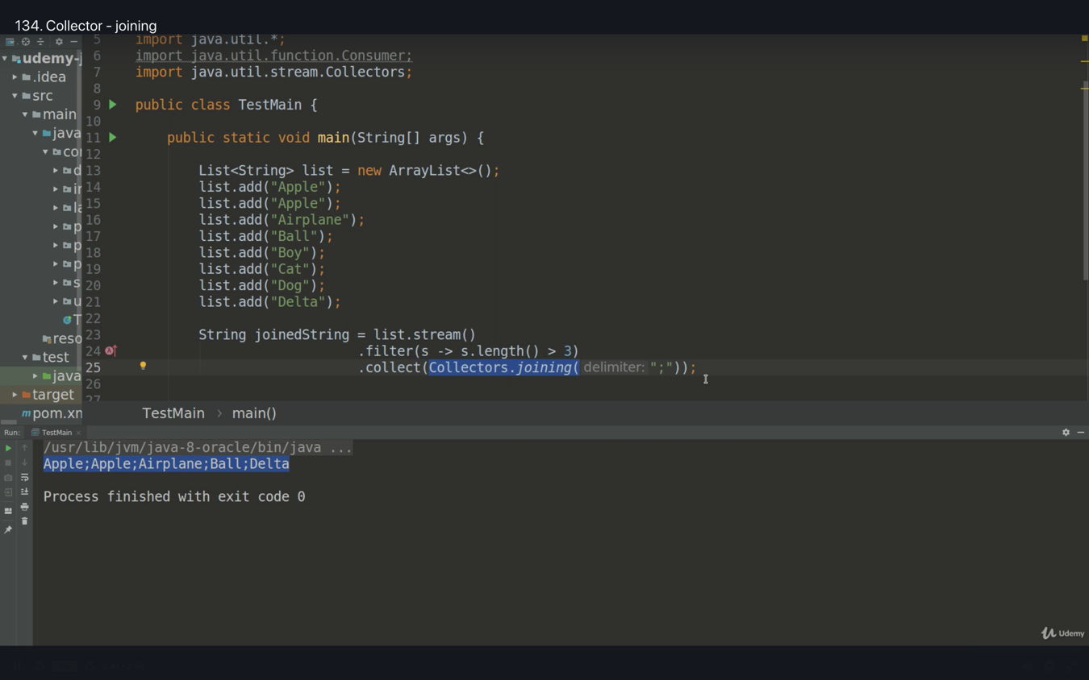

4/Collect.groupingBy (accept Predicate) and return Map of List

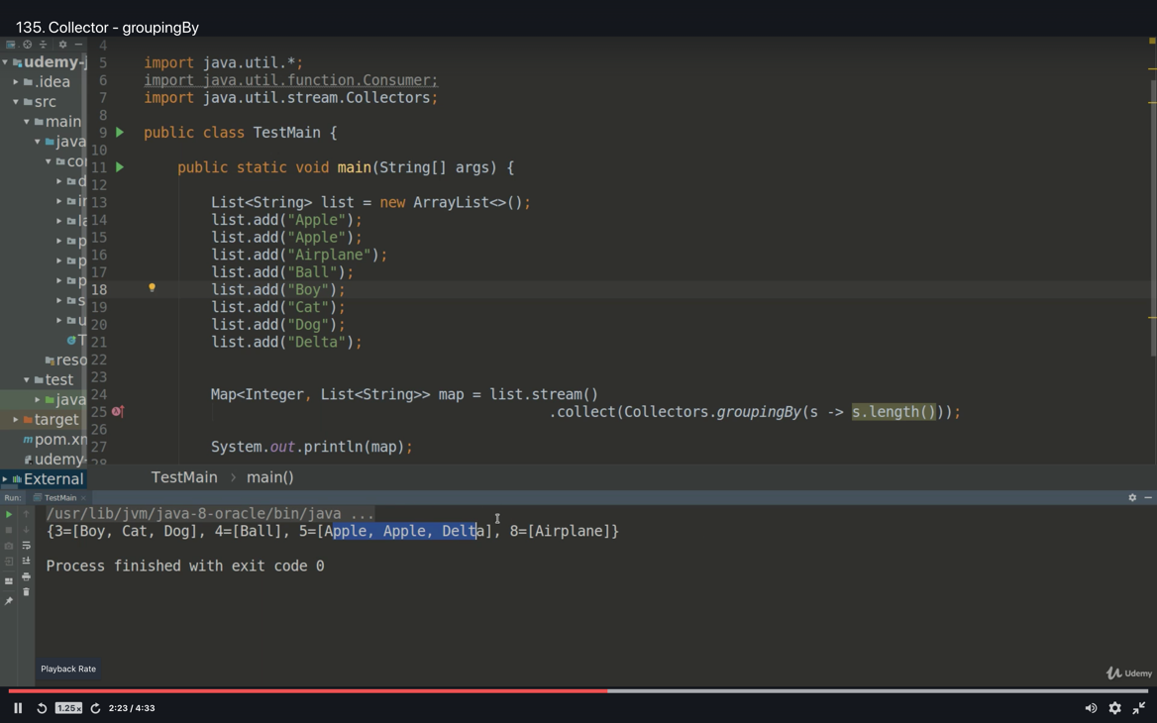

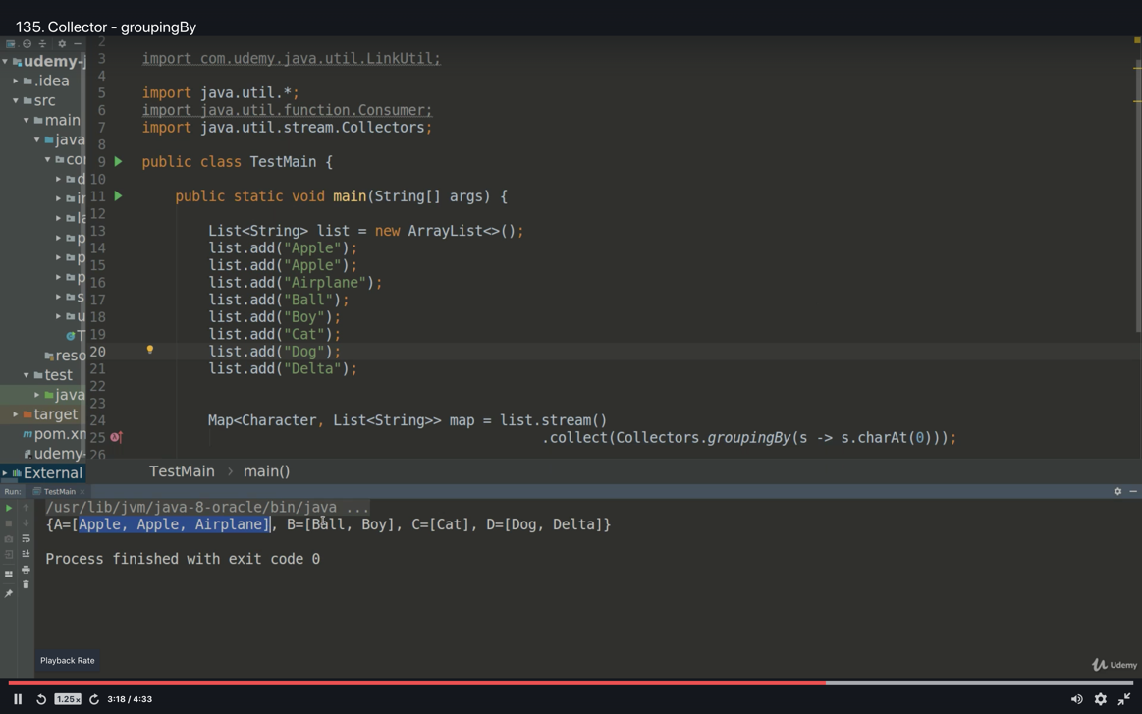

Stream – Parallel processing

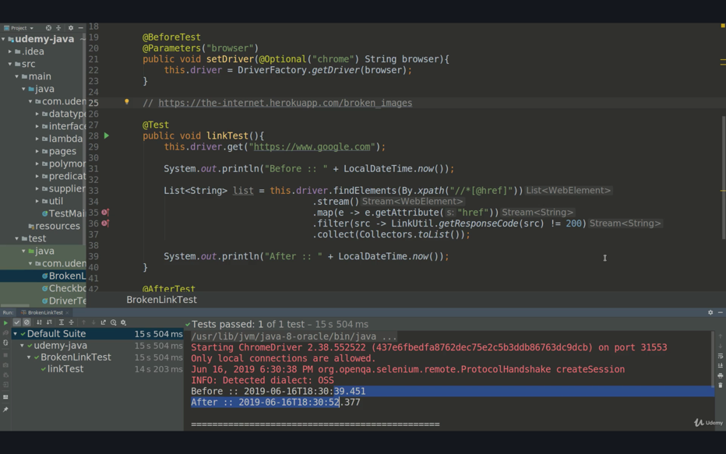

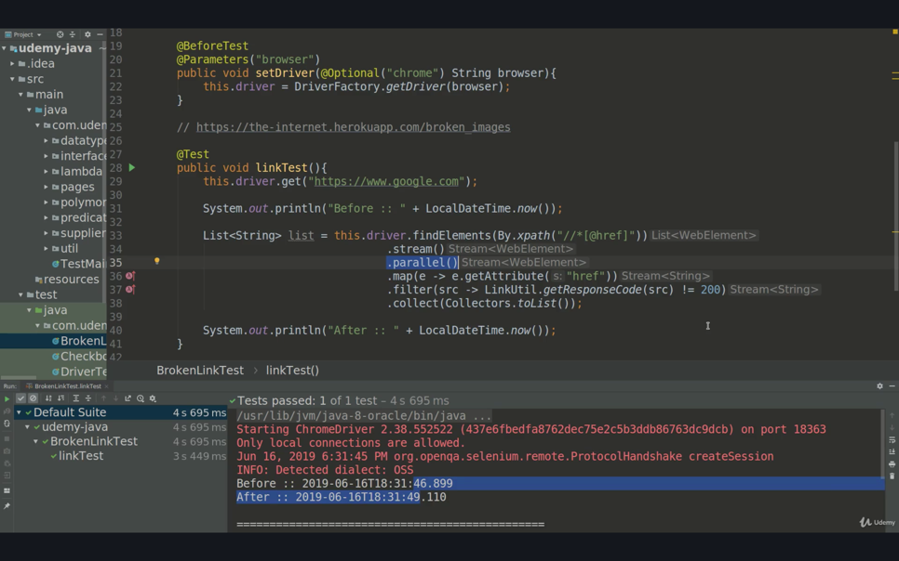

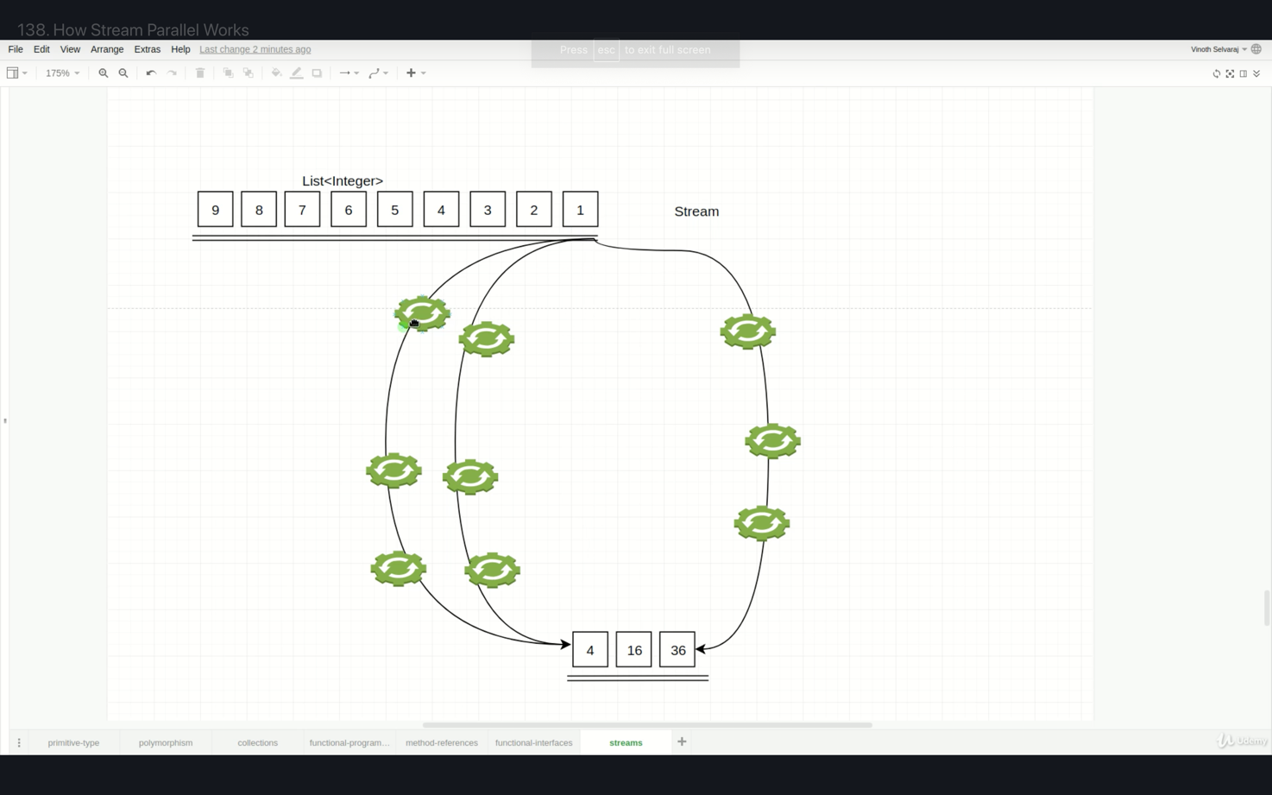

findAny() generally used with parallel() method to find the desired member of the collection.

Stream : Is it reusable

Only first forEach terminal operator will work, since one pipeline can not have multiple terminal operator. See below chart or the explanation

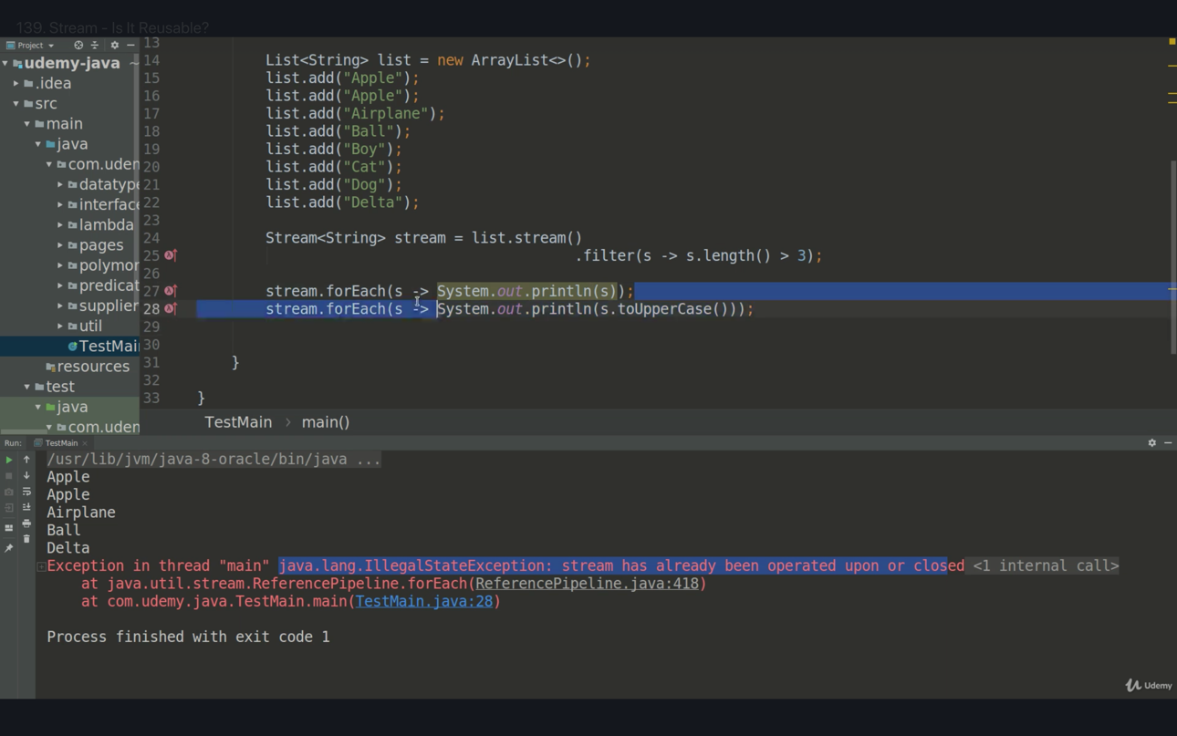

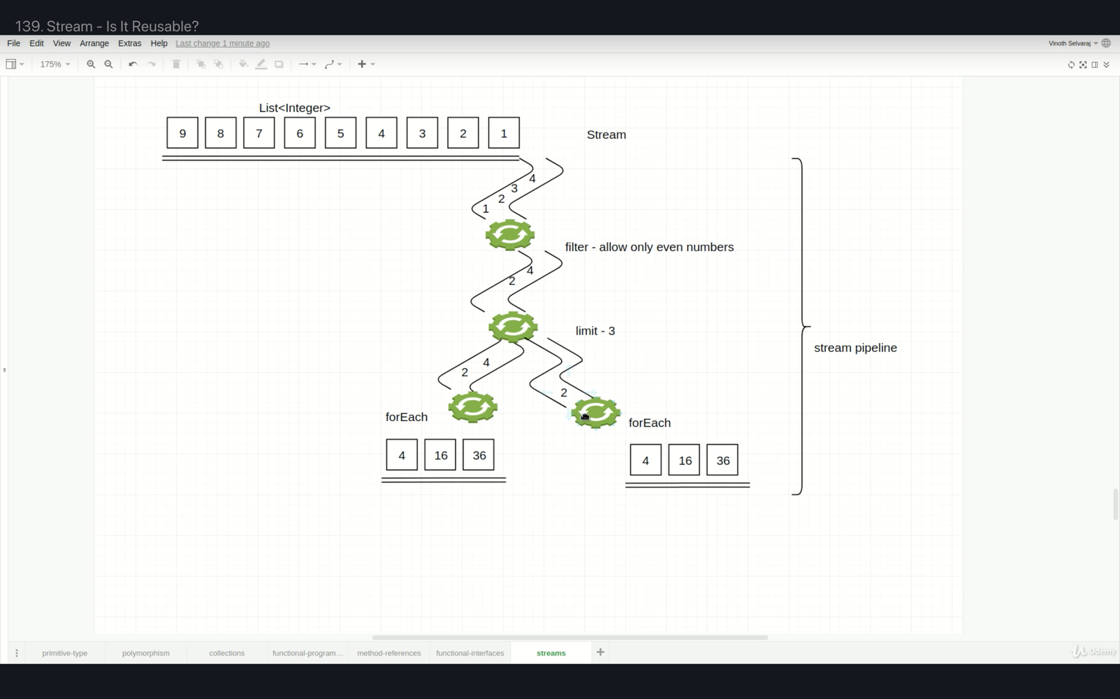

Stream source

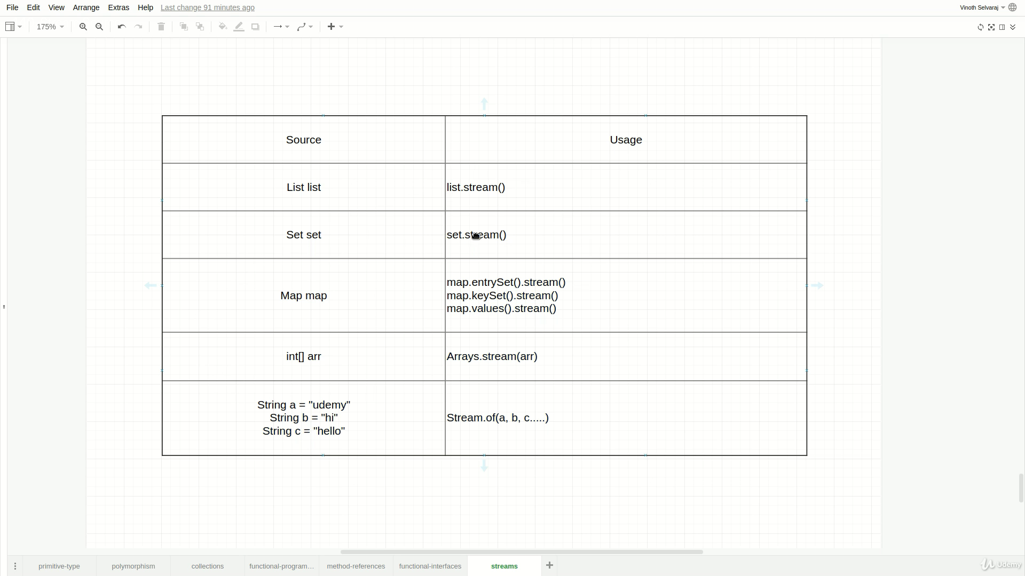

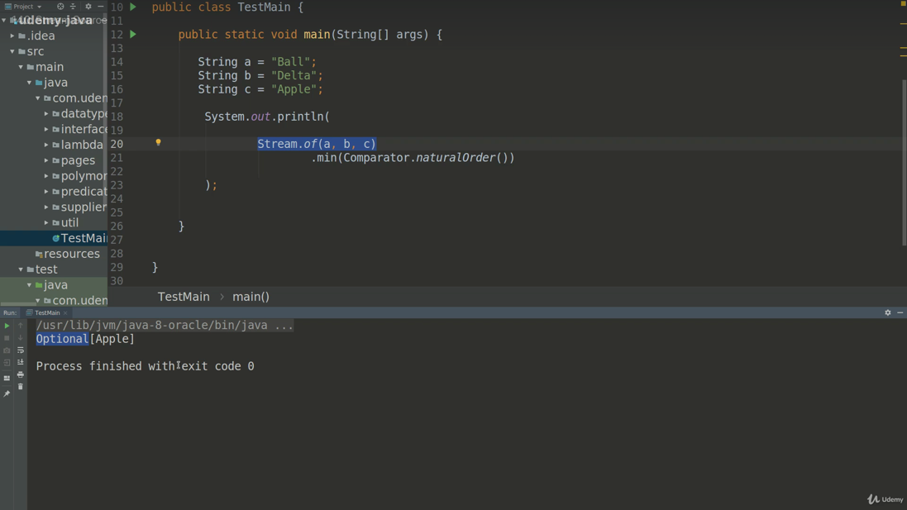

Optional

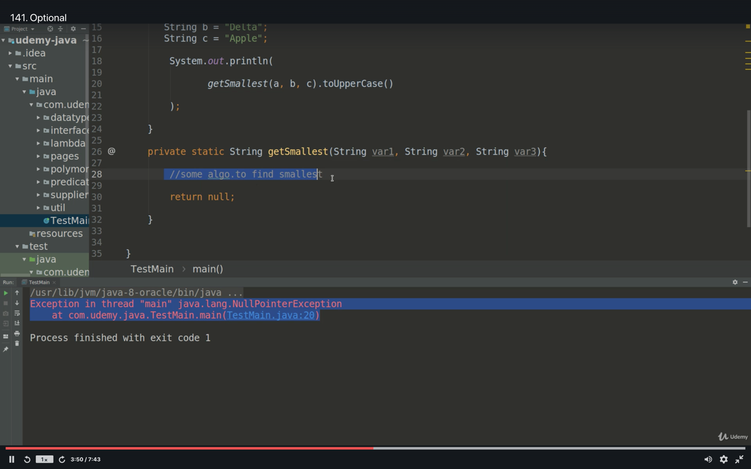

We are forcing the Not to use of uppercase method directly.

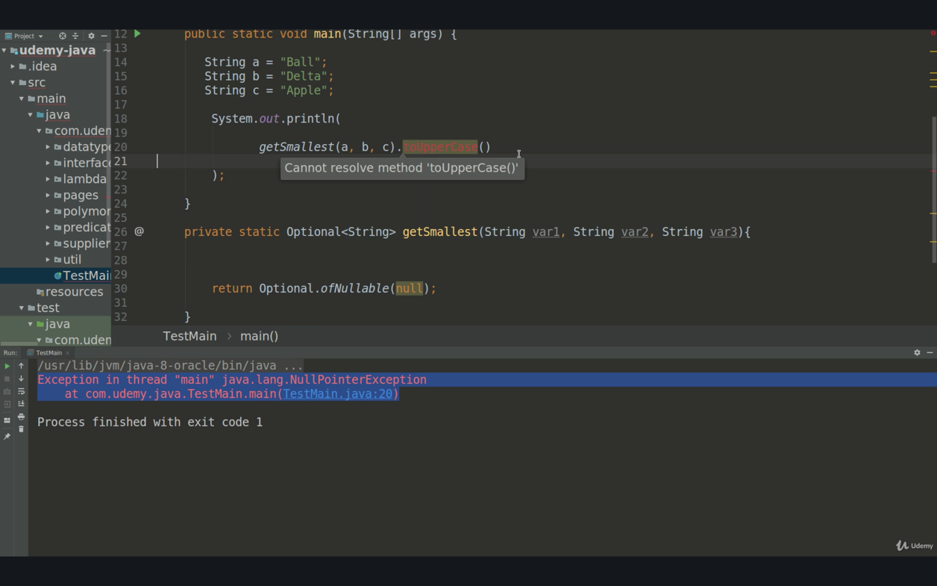

There is no exception in below code even the return value is null

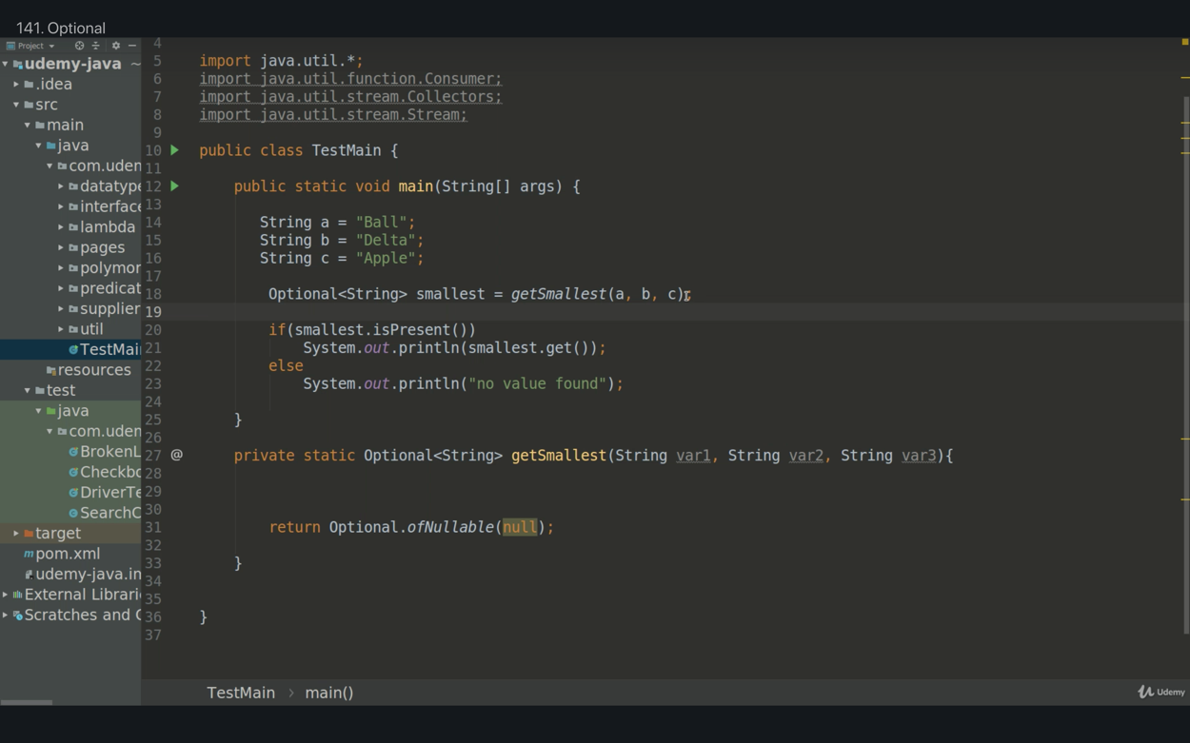

Optional forces the user to do null check. Optional of String, Optinal of WebElement, Optional of WebDriver etc…

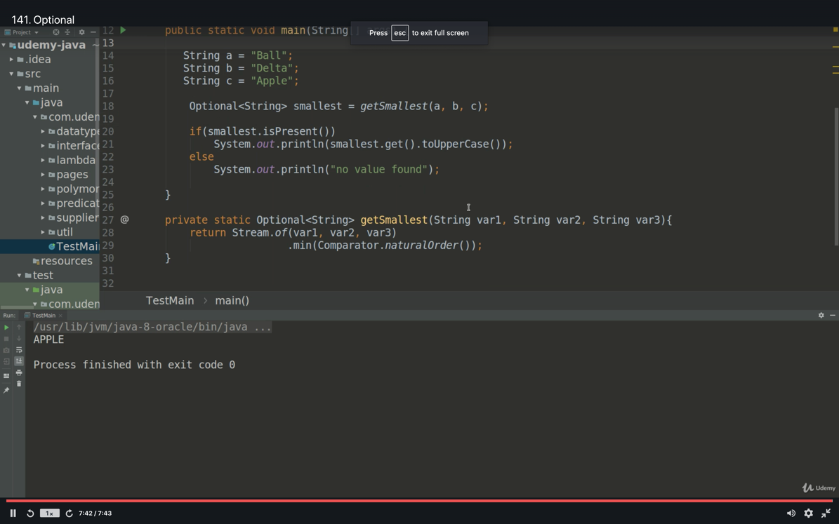

Comperator

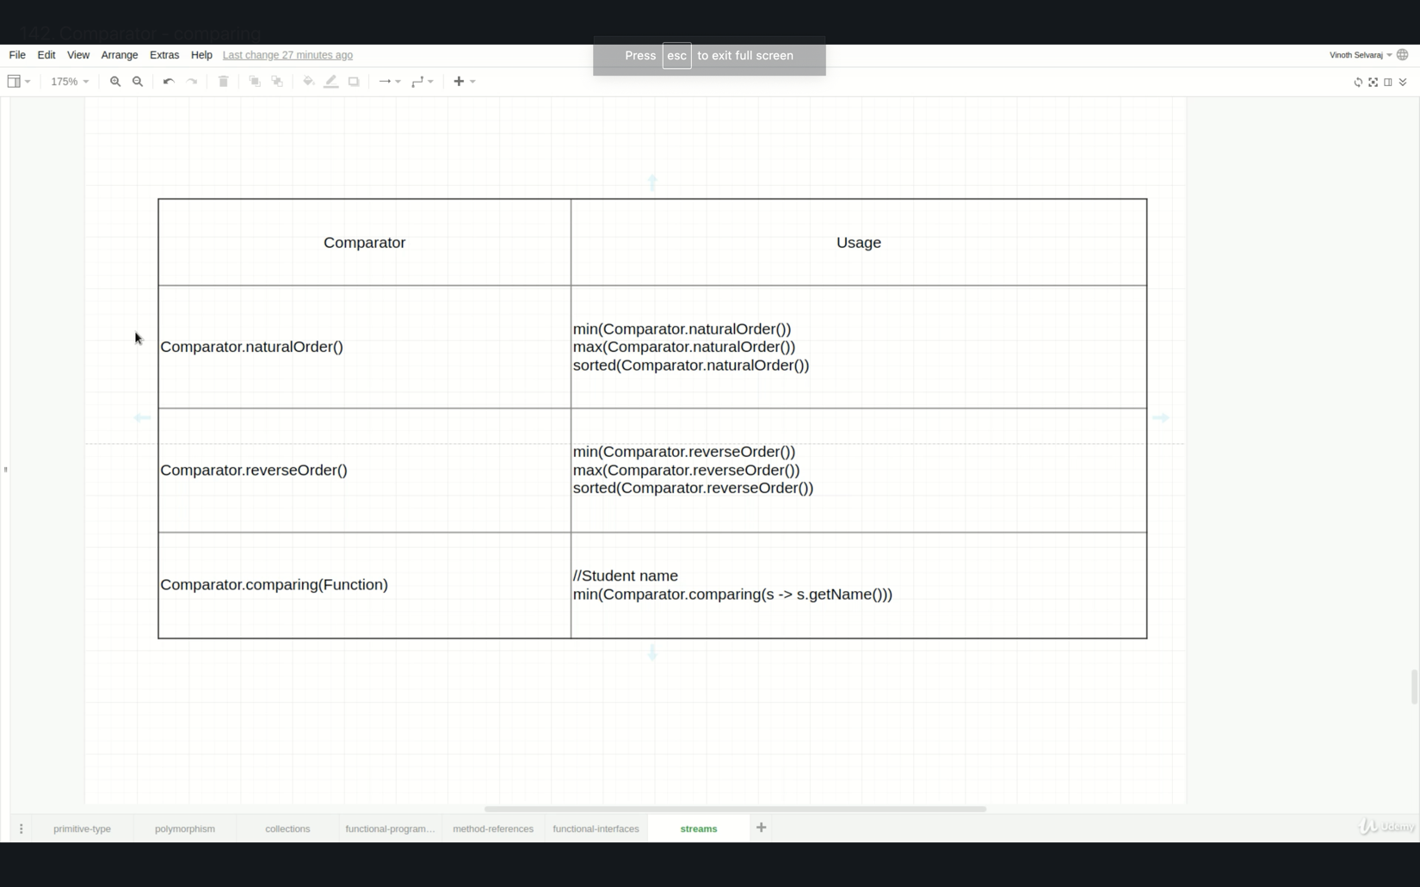

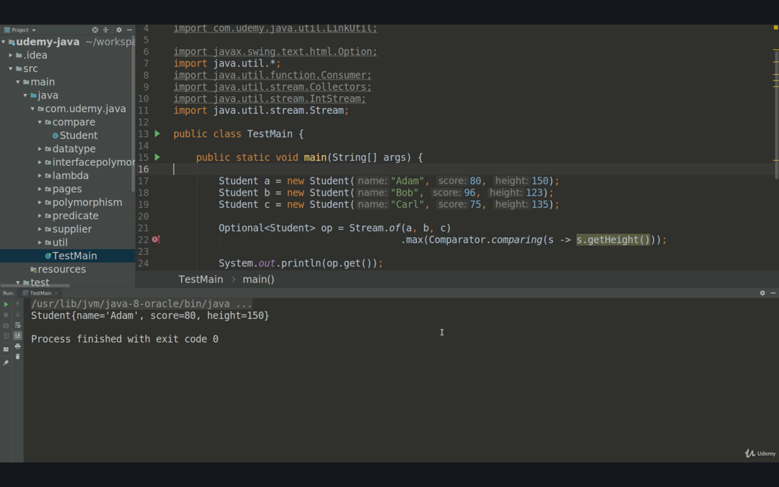

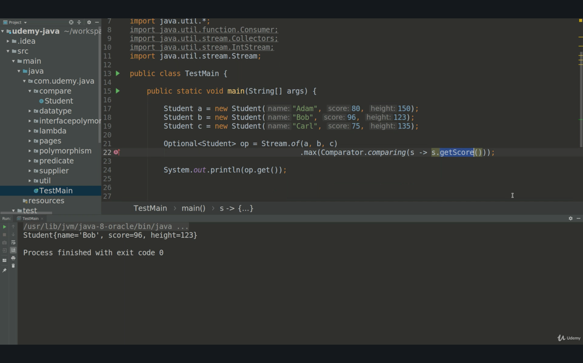

How to find sum of numbers

Use addAll() method ::

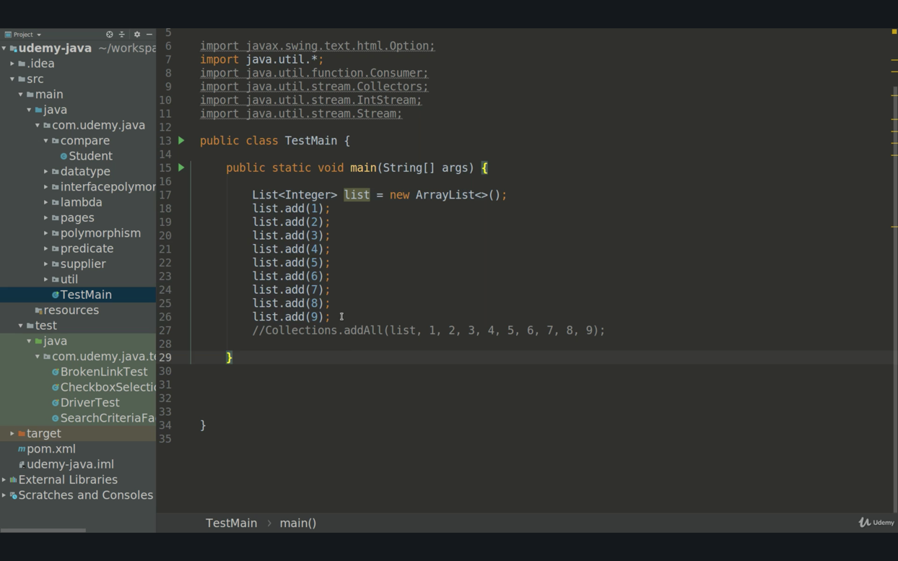

Stream reduce() method

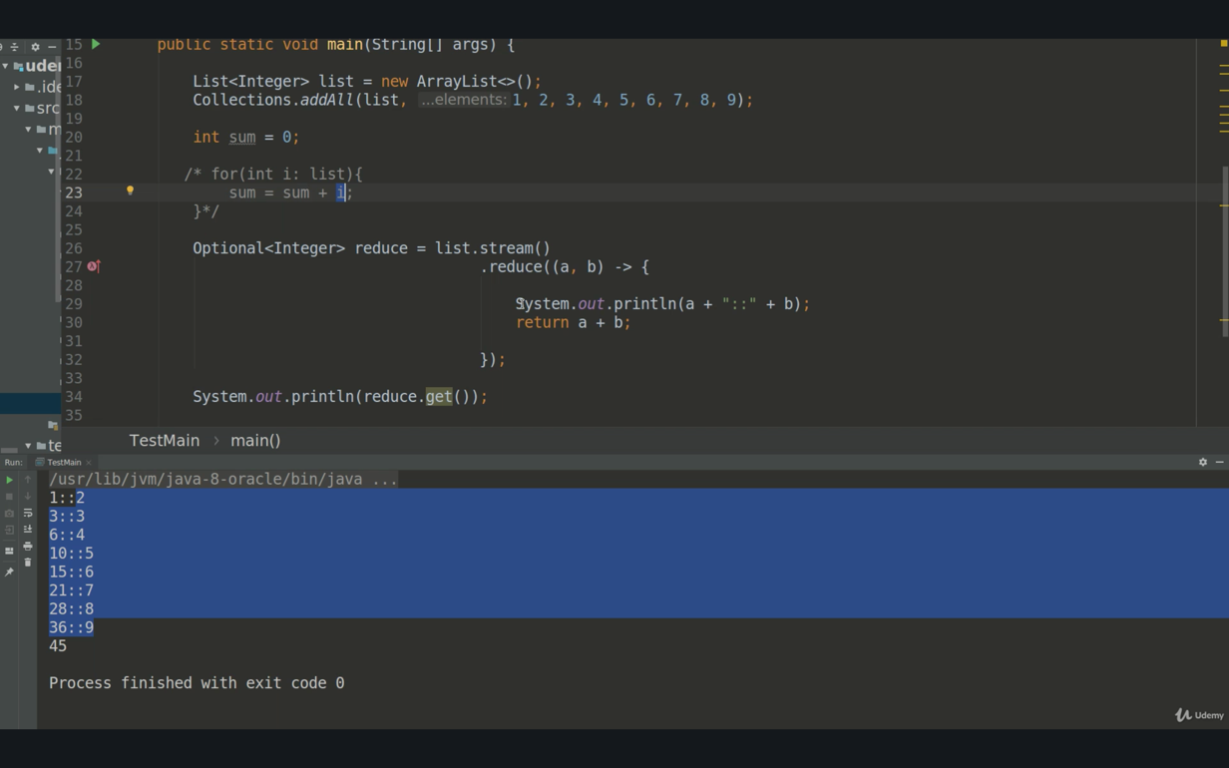

sum() & average() methods with IntStream (primitive stream)

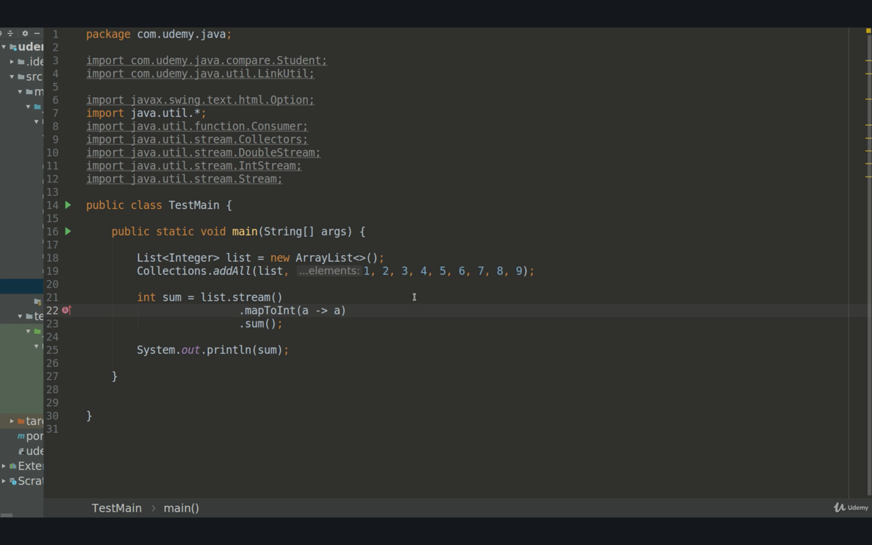

Primitive Stream

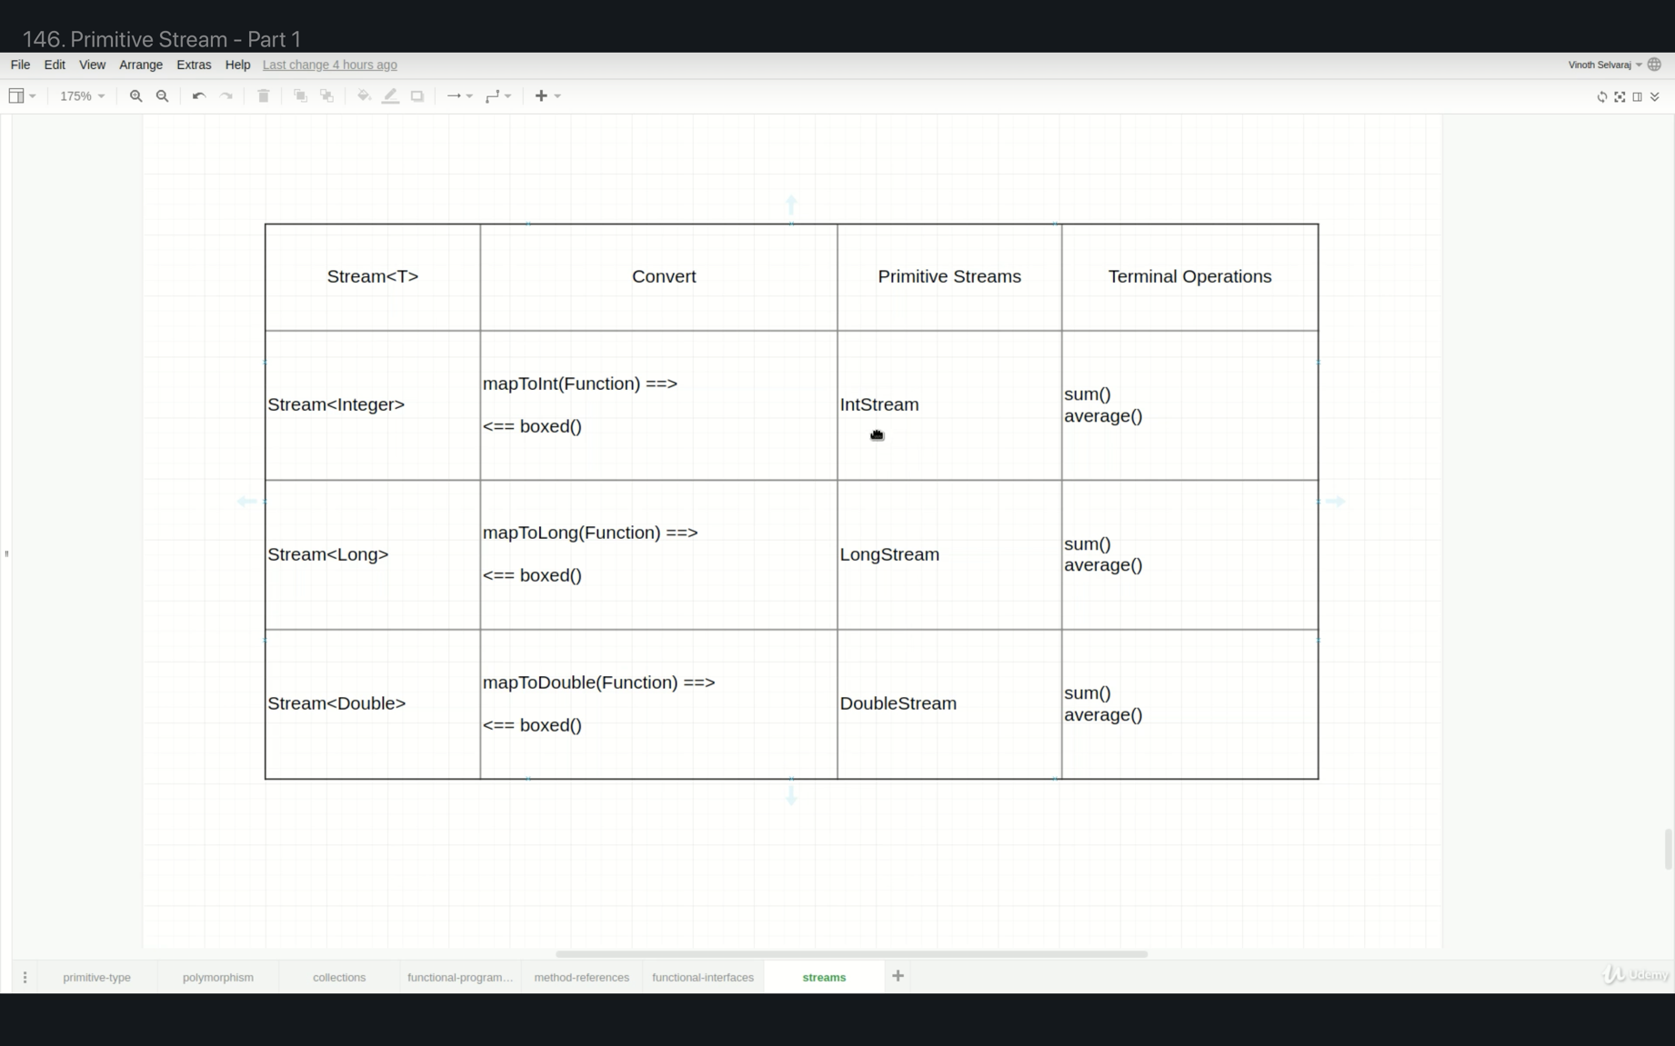

How to handle compilation error while scripting code from long to in or double to int

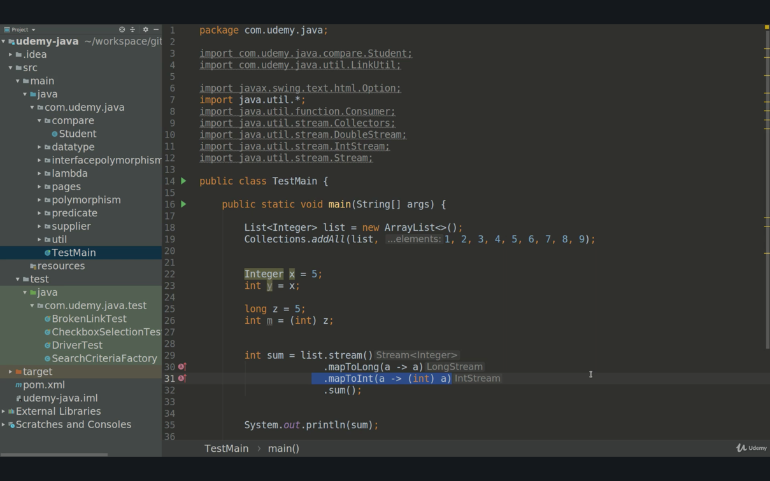

148. IntStream for Loop

We can replace the classical approach for a given number range. There are 2 different methods; range() and rangeClosed(). Rangeclosed contains the max boundary value.

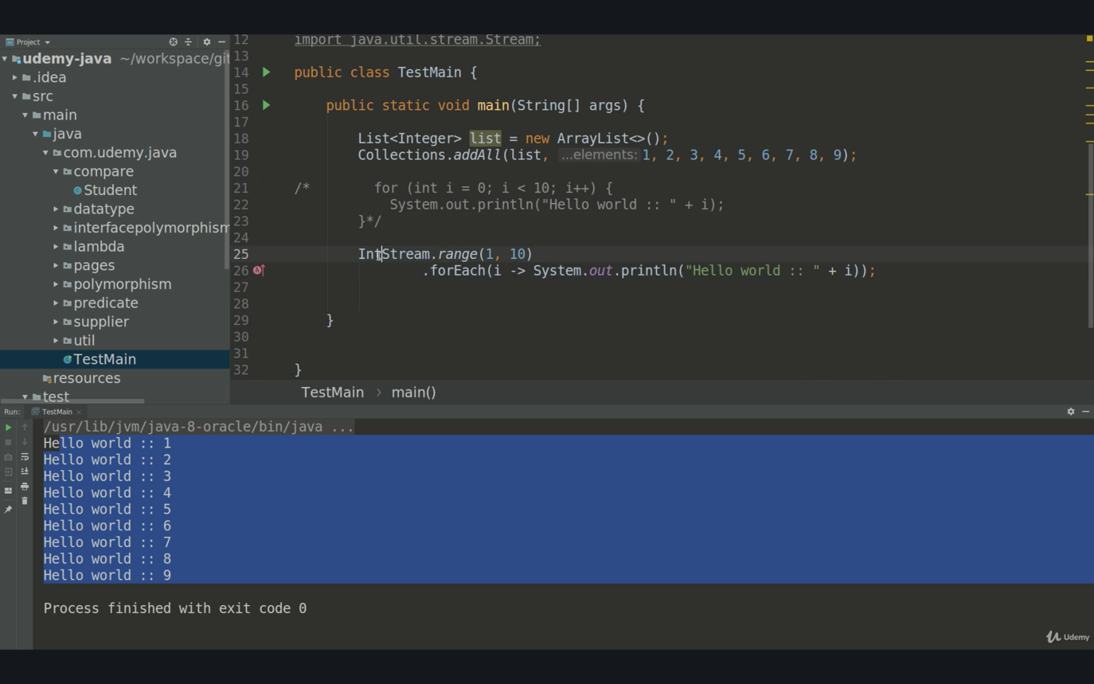

149. Default Methods In Interface

How to add new methods to current interfaces, he explain very clearly.

SUMMARY

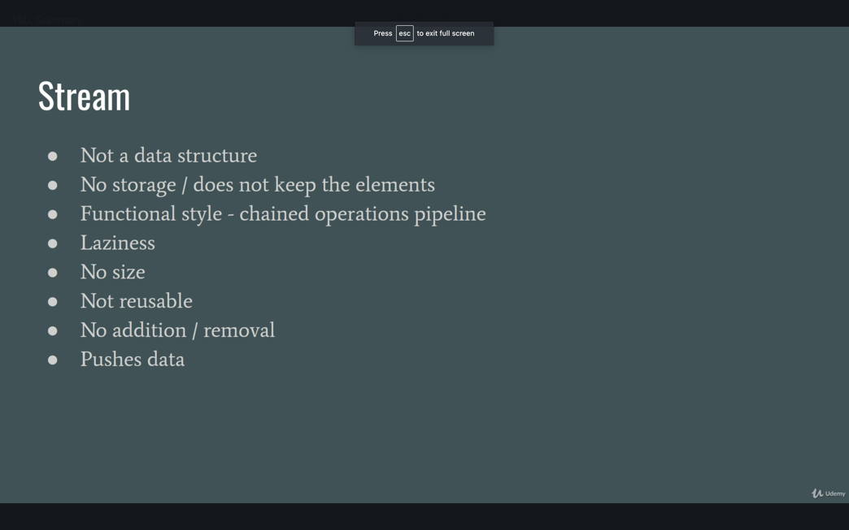

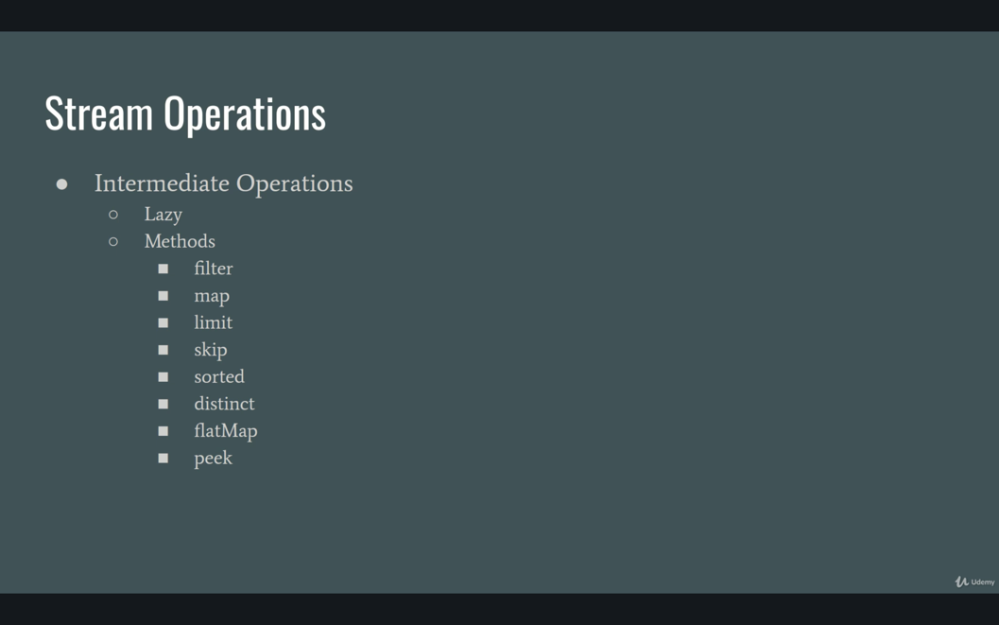

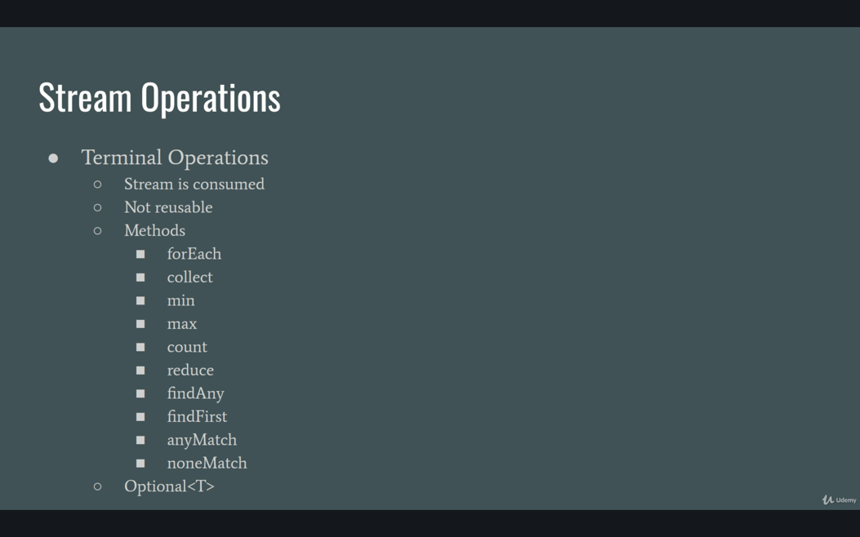

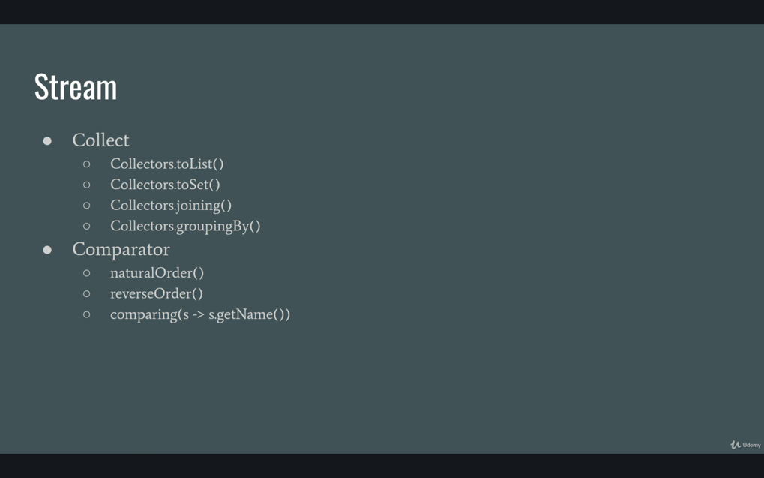

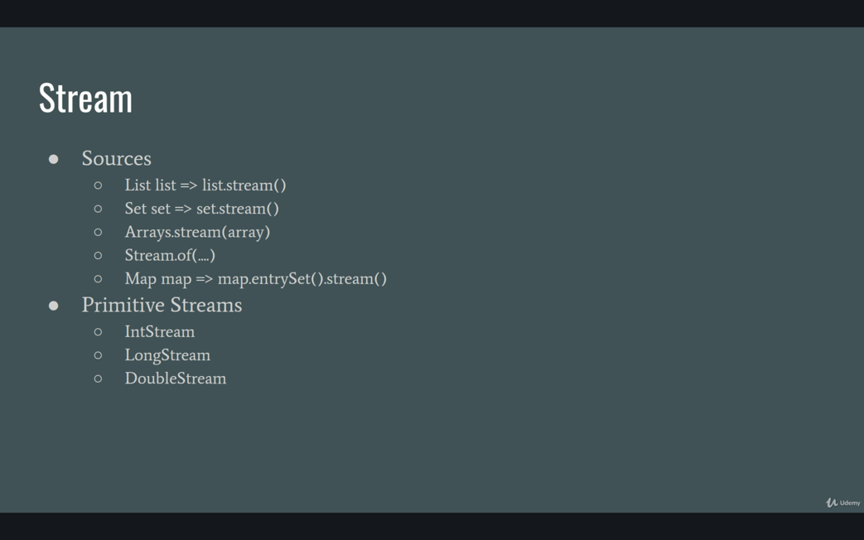

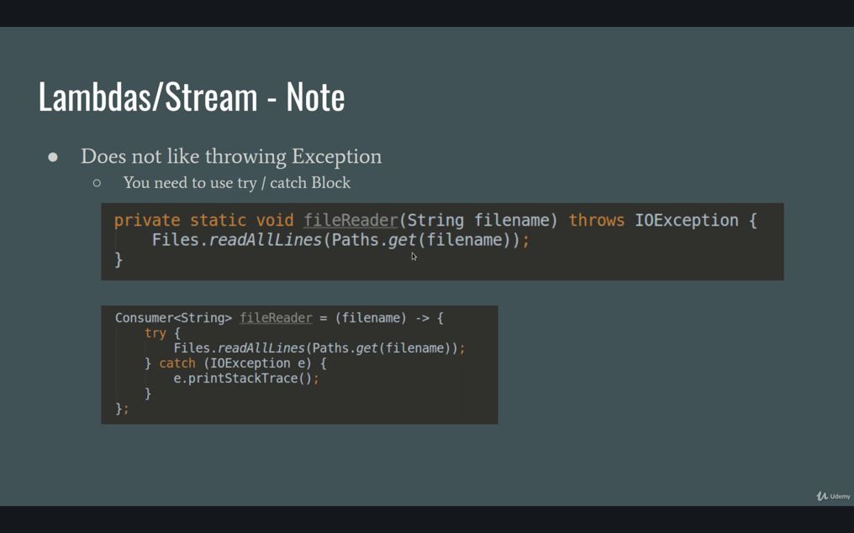

LAMBDA ASSIGNMENTS

1/ MinPriceTest

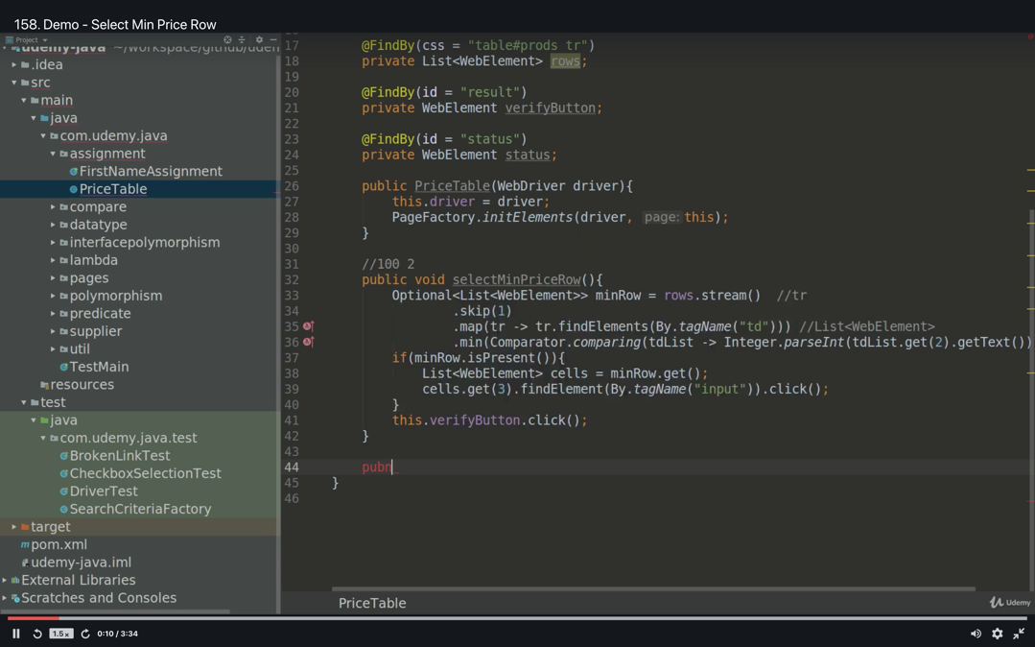

JAVA 9 NOTES

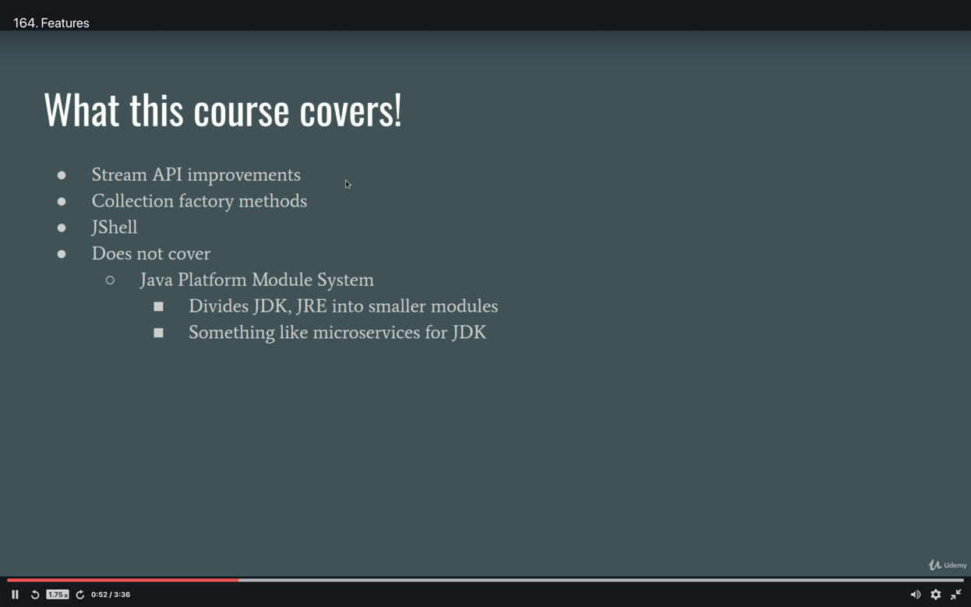

1. takeWhile() method;

Until the condition will met, java will check the all values, once the condition is met, then the check process will be over. Below example stream will work up until the 3th element in the list. It will keep doing things only the condition is met. Once the condition is not met, simply it will exit. takeWhile() is an intermediate operation.

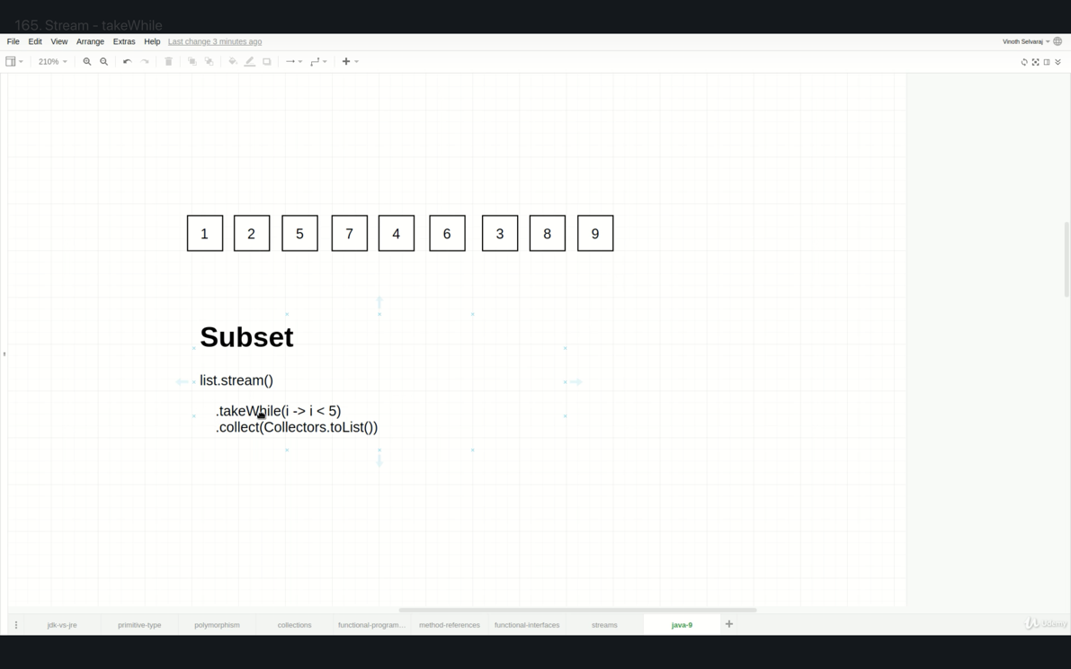

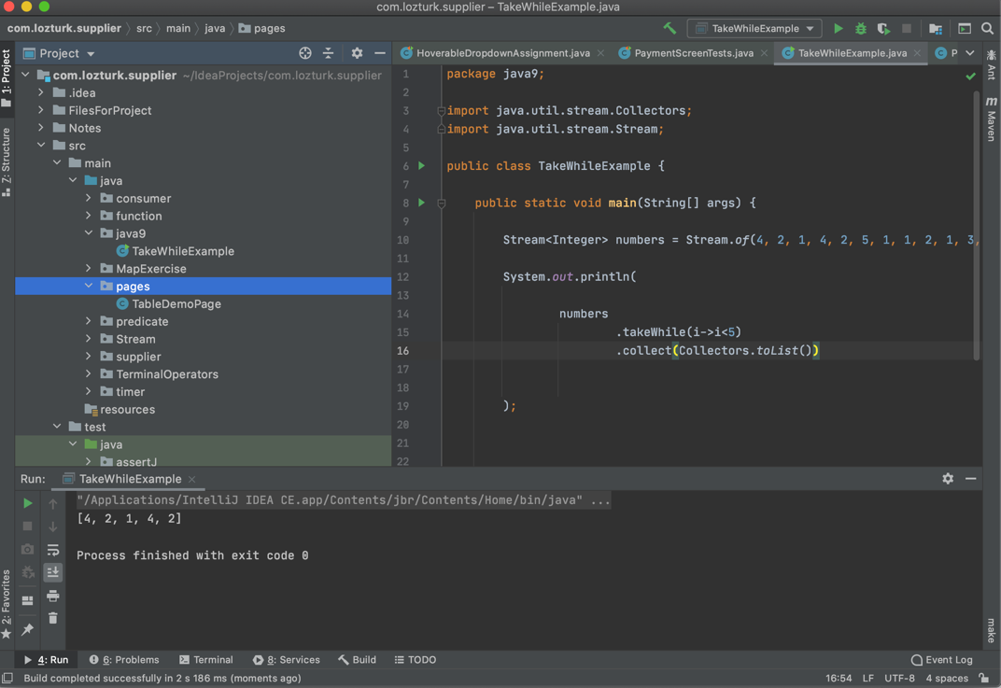

2. dropWhile() method;

dropWhile is an intermediate operation and once the condition is NOT met then it will exit and will get return the rest of the parameters in the stream pipeline.

3. Immutable List;

List<Integer> numbers = List.of(1,2,3,4,5, but not null) 🡺 it will NOT accept the null value. You can’t add or remoe or replace new parameters to this list since it’s immutable.

Mutable lists :

A/ List<Integer> numbers = new ArrayList<>();

numbers.add(1) ;

numbers.add(2) ;

numbers.add(3) ;

numbers.add(4) ;

numbers.add(null) ; 🡺 it will accept the null value

B/ Collections.addAll(list, 1,2,3,4,5,null) 🡺 it will accept the null value

C/ List<Integer> numbers = Arrays.asList(1,2,3,4,5,null). 🡺 it will accept the null value

4. Immutable Set;

Set<Integer> numbers = Set.of(1,2,3,4,5, but not null) 🡺 it will NOT accept the null value. You can’t add or remove or replace new parameters to this list since it’s immutable…….???

Mutable Set :

A/ Set <Integer> numbers = new HashSet<>();

numbers.add(1) ;

numbers.add(2) ;

numbers.add(3) ;

numbers.add(4) ;

numbers.add(null) ; 🡺 it will accept the null value….????

B/ Collections.addAll(Set, 1,2,3,4,5,null) 🡺 it will accept the null value

C/ List<Integer> numbers = Arrays.asList(1,2,3,4,5,null). 🡺 it will accept the null value

5. Immutable Map;

Map<Integer> numbers = Map.of(“a”, “10”,

“b”, “15”,

“c”, “21”

) 🡺 it will NOT accept the null value. You can’t add or remove or replace new parameters to this list since it’s immutable…….???

Mutable Map:

A/ Set <String, Integer> numbers = Map.of(

“a”, “10”,

“b”, “15”,

“c”, “21” );

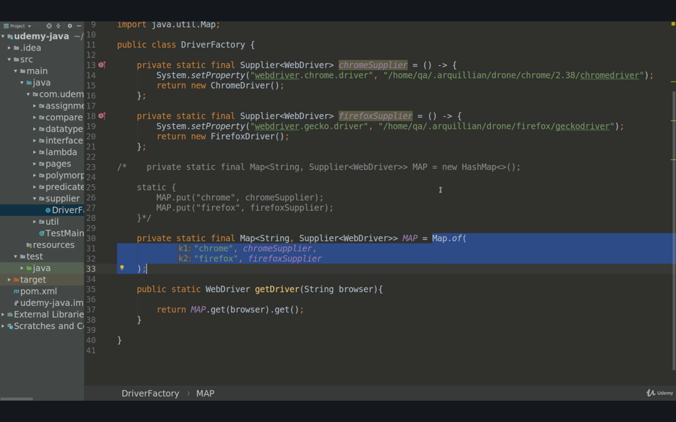

AssertJ

String Assertion (Hard)

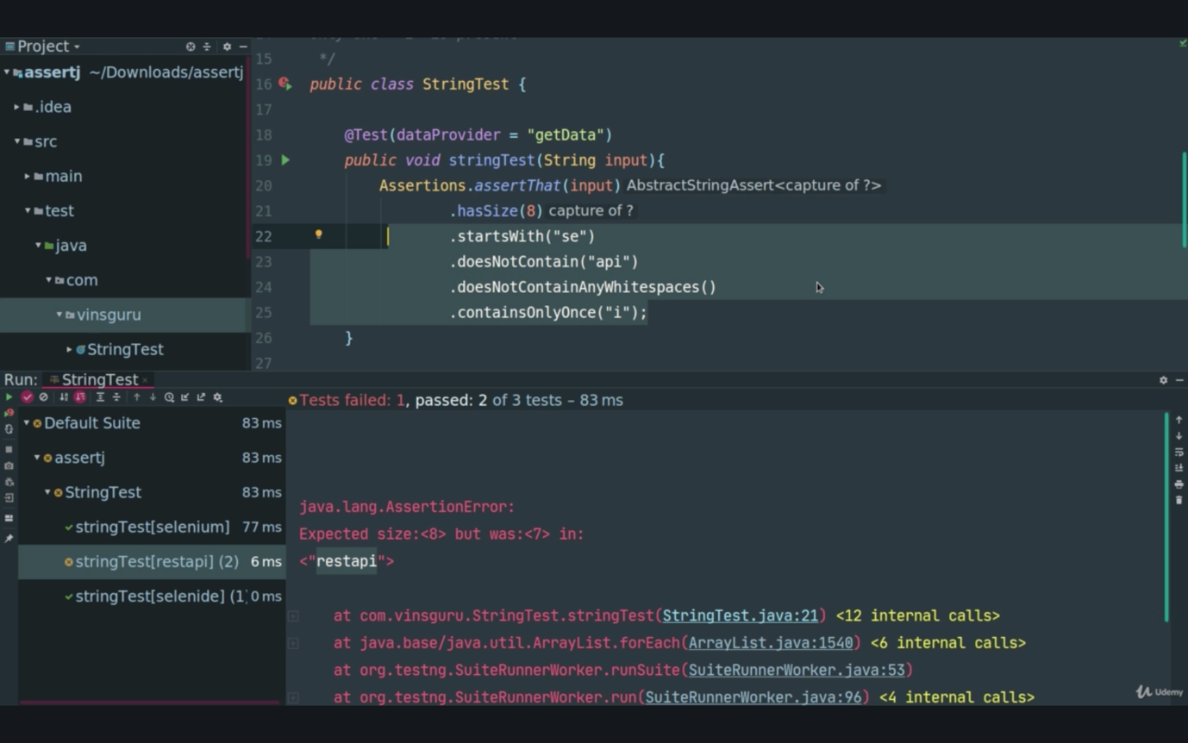

String Assertion (Soft)

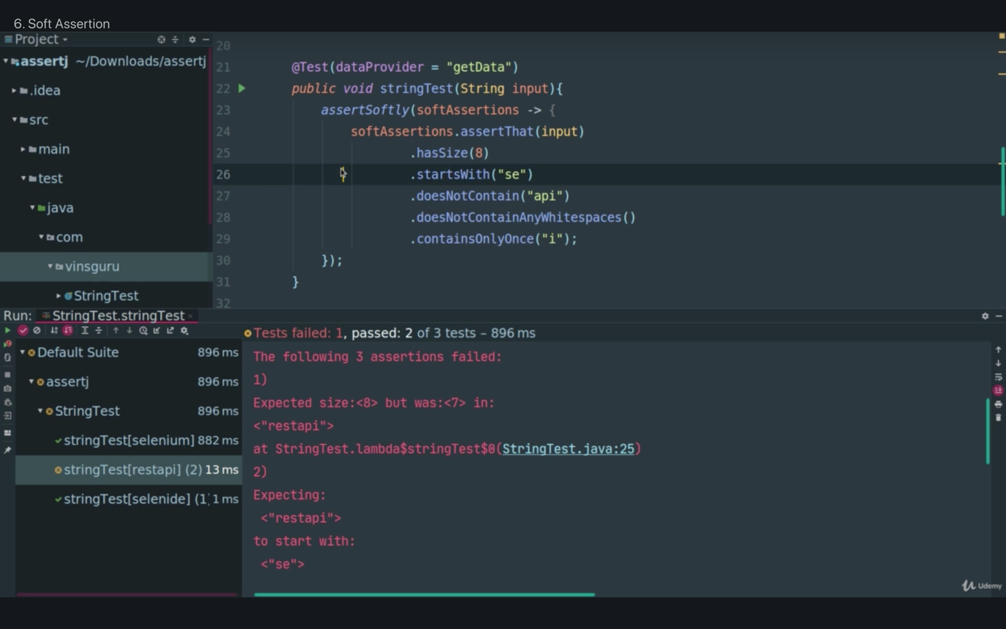

ENGLISH

1/ In addition,

2/ be enforced by

3/ compliance

4/ Safeguard :: Network architecture and software design safeguards

5/ comply with :: Your organization must comply with PCI DSS./ There can be painful side effects to non-compliance

6/ damage to reputation :: Itibarin zedelenmesi

7/ Lawsuits and insurance claims :: Davalar ve sigorta talepleri

8/ Thousands of dollars in fines per month :: Ayda binlerce dolar para cezası

9/ Email addresses are not considered cardholder data. Even so, since they are personally identifiable information, care should be taken with how and when email addresses are shared. :: E-posta adresleri, kart sahibi verileri olarak kabul edilmez. Öyle bile olsa, kişisel olarak tanımlanabilir bilgiler olduklarından, e-posta adreslerinin nasıl ve ne zaman paylaşılacağına dikkat edilmelidir.

10/ Even so, :: Oyle bile olsa,

11/ These interactions should have no impact on the security of cardholder data—though it’s always a good idea to treat customers with respect. :: Müşterilere saygılı davranmak her zaman iyi bir fikir olsa da, bu etkileşimlerin kart sahibi verilerinin güvenliği üzerinde hiçbir etkisi olmamalıdır.

12/ The only reason to comply with PCI DSS regulations is to avoid hefty fines for non-compliance. :: PCI DSS düzenlemelerine uymanın tek nedeni, uyumsuzluk nedeniyle ağır para cezalarından kaçınmaktır.

13/ Avoid the hefty fines :: ağır para cezalarından kaçınmak

14/ If the technology has been regularly updated, that's all that matters. There is nothing you can do to positively or negatively impact data security. :: Teknoloji düzenli olarak güncellendiyse, önemli olan tek şey budur. Veri güvenliğini olumlu veya olumsuz etkilemek için yapabileceğiniz hiçbir şey yoktur.

15/ that's all that matters :: önemli olan tek şey budur

16/ PCI DSS specifies parameters for logging and storing transaction data. These parameters are in place to ensure data remains secure. :: PCI DSS, işlem verilerinin günlüğe kaydedilmesi ve depolanması için parametreleri belirtir. Verilerin güvenli kalmasını sağlamak için bu parametreler mevcuttur.

17/ These parameters are in place :: bu parametreler mevcuttur

18/ Implement best practices in your daily routines to improve data security :: Veri güvenliğini artırmak için günlük rutinlerinizde en iyi uygulamaları uygulayın

19/ Implement the practices

20/ Follow documented procedures for handling, transmitting, and storing data :: Verilerin işlenmesi, iletilmesi ve depolanması için belgelenmiş prosedürleri izleyin/

21/ Follow documented procedures

22/ Handling the data :: verileri islemek

23/ Keep equipment and passwords secure : Ekipmanı ve parolaları güvende tutun

24/ keep secure

25/ Ensure confidential information stays confidential :: Gizli bilgilerin gizli kalmasını sağlayın

26/ stay confidential :: gizli kalmak

27/ Keep work and personal data separate :: İş verilerini ve kişisel verileri ayrı tutun

28/ keep separate : ayri tutmak

29/ Audit trails should track and document all individual points of contact with cardholder data :: Denetim izleri kart sahibi verileriyle tüm bireysel temas noktalarını izlemeli ve belgelemelidir.

30/ remain compliant with PCI DSS. :: PCI DSS ile uyumlu kalın.

31/ If you see a coworker mishandling cardholder data, alert your supervisor. :: Kart sahibi verilerini hatalı kullanan bir iş arkadaşınız görürseniz, yöneticinizi uyarın.

32/ mishandling cardholder data :: Kart sahibi verilerini hatalı kullanmak

33/ coworker :: iş arkadaşı

34/ alert your supervisor :: yöneticinizi uyarın

35/ It’s never appropriate to write down or copy cardholder data for personal use. :: 78/5000

Kişisel kullanım için kart sahibi verilerini yazmak veya kopyalamak asla uygun değildir.

36/ It’s never appropriate :: asla uygun değildir

37/ You should never leave cardholder data out in the open. Rita should have put the logs in a locked drawer or cabinet, or waited until her boss returned and handed them to him personally. :: Kart sahibi verilerini asla açıkta bırakmamalısınız. Rita, kütükleri kilitli bir çekmeceye veya dolaba koymalı ya da patronunun geri dönüp onları şahsen kendisine vermesini beklemeliydi.

38/ leave cardholder data out in the open :: Kart sahibi verilerini açıkta bırakmak

39/ hand them to him personally. :: şahsen kendisine vermek

40/ Let the supervisor determine if data security has been compromised. :: Amirinizin veri güvenliğinin ihlal edilip edilmediğini belirlemesine izin verin.

41/ compromise :: risk, venture, put at risk, jeopardize, put in jeopardy, adventure :: Ihlal etmek, tehlikeye atmak

42/ data security has been compromised :: eri güvenliğinin ihlal edildi

43/ Scammers will tamper with card readers :: Dolandırıcılar, kart okuyuculara müdahale edecek.

44/ tamper with :: müdahale etmek, karistirmak, kurcalamak

45/ Small cameras can record PIN sequences :: Küçük kameralar PIN dizilerini kaydedebilir

46/ Be firm with any customers who call in to access their accounts. They must accurately provide identifying information. Don’t get tricked into helping a scammer. :: Hesaplarına erişmek için arayan tüm müşterilere karşı sağlam olun. Tanımlayıcı bilgileri doğru bir şekilde sağlamalıdırlar. Bir dolandırıcıya yardım etmek için kandırılmayın.

47/ Be firm :: karali olun

48/ call in :: telefon aramasinin gelmesi,

49/ Don’t get tricked into helping a scammer. :: Bir dolandırıcıya yardım etmek için kandırılmayın.

50/ Con artists :: dolandirici

51/ Be on alert for distraction techniques that lure you away from your computer or your register :: Sizi bilgisayarınızdan veya kayıt defterinizden uzaklaştıran dikkat dağıtma tekniklerine karşı tetikte olun

52/ lure :: yemlemek bait, fodder, lure

53/ Customers and employees often face less scrutiny, which makes it easier to operate a scam. :: Müşteriler ve çalışanlar genellikle daha az incelemeyle karşı karşıya kalır, bu da bir dolandırıcılık yapmayı kolaylaştırır.

54/ scrutiny :: dikkatli inceleme, ince eleyip sık dokuma, oyların yeniden sayımı

55/ scrutiny, subtlety

56/ to operate a scam :: dolandiricilik yapmak

57/ Be mindful of customers who linger too long or who seem out of place. :: Çok uzun süre oyalanan veya yerinde görünmeyen müşterilere karşı dikkatli olun.

58/ Stalk, blackmail, or publicly humiliate an individual. : Bir kişiyi takip edin, şantaj yapın veya alenen aşağılayın.

59/ to plan to inflict personal harm on an individual. : bir bireye kişisel zarar vermeyi planlamak.

60/ Governments can impose hefty fines or penalties for a data breach. :

61/ Items of PII that are considered lower risk have minimal ramifications if compromised. : Daha düşük risk olarak kabul edilen PII öğeleri, tehlikeye atılırsa minimum sonuçlara sahiptir.

62/ A breach of PII that has the potential to lead to a loss of life, loss of livelihood, or inappropriate physical detention. : Can kaybına, geçim kaynağının kaybına veya uygunsuz fiziksel tutuklamaya yol açma potansiyeline sahip bir PII ihlali.

63/ industry standards for handling data

64/ Trust your instincts, even if it seems small or insignificant.

65/ Report it appropriately.

66/ It is a best practice to use as little PII as possible and to make it anonymous when you can.